

**BIONIC ENGINEERS**

Bengaluru, Karnataka, India

AN

INTERNSHIP REPORT

ON

“Tribute To Doctors”

**Bachelor of Engineering**

**In**

**Mechanical Engineering**

**Submitted by: RAMKUMAR DEVARADDI (1RI18ME022)**



**R R INSTITUTION OF TECHNOLOGY 2021**

Bangalore-560090

**TABLE OF CONTENTS**

Table of contents

Overview of the Project 3

About importance of plants 4

About importance of nurseries 5

Tools Used 6

Implementation 7

Snapshots 383

Bibliography 389

## OVERVIEW OF THE PROJECT

**Project Name**: Leaf Now

**Team Members**: Ramkumar Devaraddi

Vachana Deepti

Sahana R

Suhas P

This project is based on Web Development And its Applications. The main objective of this project is to learn the implementation of HTML, CSS and JavaScript. The basic webpage of this project is created using HTML and styling of the webpage is done using CSS.

*This webpage is about connecting plant enthusiasts.*

A nursery plant center offers its customers all types of young plants that are local (native), imported, and exotic. A nursery customer could be a home gardener, landscape gardener, or even a commercial farmer. A nursery business must cater to a wide range of plants that will be indoor to outdoor plants and container to earth planting plants. Nurseries must be equipped with all kinds of horticulture requirements such as all sorts of plant seeds, soil mix, fertilizers, insecticides, garden chemicals, garden tools, and be able to answer backyard inquiries. Apart from plants, the nurseries have to have the ability to assist in all kinds of inquiries and purchases. Leaf now is the leading organization delivering and promoting climate positive and resilient farming at an increasingly global level. Having a shop on your own and sell these ornamental plants for users who buy for gifting purposes. To inspire and enable more circular approaches to farming and food systems through integrated, regenerative and vibrant nature-based solutions, that deliver productivity and prosperity among farmers, enriches the environment and positively engages young people and wider society.

### About the importance of plants

Plants are critical to the balance of nature, people's lives, and our environment. According to the National Group of Food, plants constitute the ultimate source of food for over 95 percent of the world's population. It is true that approximately 7,000 plant species are eaten nowadays.

Plants help manage the water cycle, which is one of the reasons we have clean water.

Our water cycle will be disturbed and our oxygen supply will be reduced if plants are not there since they enhance oxygen levels and lower carbon dioxide levels. In summary, humanity will not be able to exist in the absence of plants. Plants keep the ecology in balance.

They also aid in the purification of the air we breathe. They contribute to the fight against global warming by keeping the world temperature stable, saving us from the sweltering heat.

Plants combat climate change by collecting carbon dioxide generated by numerous environmental processes and releasing oxygen into the environment. Plants reduce air temperature by controlling the intensity of the heat and reducing the amount of carbon dioxide generated. Furthermore, they reduce temperature by giving shade to homes and streets, as well as by releasing water vapor into the environment, which lessens the heat created.

### About the importance of nurseries

Plants are extremely beneficial to the environment and all living creatures. Plants absorb CO2 and emit oxygen through their leaves, which humans and other creatures require to breathe. Plants are essential to the survival of all living things; they eat and live in them. Plants also aid in the purification of water.

Apart from that, why is it called a plant nursery? A nursery, according to my dictionary, is “a facility where plants are grown for sale, transplanting, or experimentation.” The term "grown" in this context appears to imply that plants at a nursery are supposed to increase in size while there.

Plant nurseries assist to connect people who are interested in nature and plants. They also aid in the growth of plants and the preservation of the natural environment, something we humans lack in today's fast-paced world.

People have ceased caring about our environment in our technologically advanced and rapidly developing world, and plants are given the least importance, but we strive to supply and satisfy the needs of plant enthusiasts in this busy world, and to help them connect with the plants of their choosing.

**TOOLS USED**

##### Software:

* Visual Studio Code 2019.
* Google Chrome or Microsoft Edge of latest version.
* Front End: HTML, CSS
* Linux 7.1 or Windows XP/7/8/10 OS or Mac OS
* PHP server-XAMPP, WAMP, etc.
* MySQL Database – For managing data entered by the user. Editor –Visual Studio Code(recommended)
* Front End Requirements – HTML, CSS, JavaScript

##### Hardware:

* Pentium 200-MHz computer with a minimum of 64 MB of RAM (128 MB of RAM recommended).
* Monitor with a refresh rate of at least 40Hz for a smooth GUI experience (optional).

**IMPLIMENTATION**

**Source Code P2 (HTML):**

<!DOCTYPE html>

<html lang="en">

<head>

<meta charset="UTF-8" />

<meta name="viewport" content="width=device-width, initial-scale=1.0" />

<title>Leaf Now</title>

<link rel="stylesheet" href="/css/style.css" />

</head>

<body>

<div class="container">

<div class="navbar">

<div class="menu">

<h1 class="logo">LEAF<span>NOW</span></h1>

<div class="hamburger-menu">

<div class="bar"></div>

</div>

</div>

</div>

<div class="main-container">

<div class="main">

<header>

<div class="overlay">

<div class="inner">

<h2 class="title">LEAF NOW</h2>

<p>

Ever since industrialization started the care for plants has

made it to our least priority list, Even though mankind

requires plants to balance the food chain that he’s a part of,

but the plant enthusiasts are everywhere, be it big

metropolitan cities or rural areas, so we aim to bring in a

platform that can connect these plant/nature enthusiasts and

help them exchange/sell them plants or donate seeds/plants as

part of the green initiative that we started 2 years back.

</p>

<button class="btn">Read more</button>

</div>

</div>

</header>

</div>

<div class="shadow one"></div>

<div class="shadow two"></div>

</div>

<div class="links">

<ul>

<li>

<a href="home.html" style="--i: 0.05s">Home</a>

</li>

<li>

<a href="products.html" style="--i: 0.2s">Products</a>

</li>

<li>

<a href="contact.html" style="--i: 0.15s">Contact Us</a>

</li>

<li>

<a href="about.html" style="--i: 0.25s">About Us</a>

</li>

<li>

<a href="profile.html" style="--i: 0.3s">Profile</a>

</li>

</ul>

</div>

</div>

<script src="/js/main.js"></script>

</body>

</html>

**Home.html:**

<!DOCTYPE html>

<html lang="en">

<head>

<meta charset="UTF-8" />

<meta http-equiv="X-UA-Compatible" content="IE=edge" />

<meta name="viewport" content="width=device-width, initial-scale=1.0" />

<link rel="stylesheet" href="/css/home.css" />

<title>Home</title>

</head>

<body>

<header>

<div class="wrapper">

<div class="logo"></div>

<ul class="nav-area">

<li><a href="home.html">Home</a></li>

<li><a href="products.html">Products</a></li>

<li><a href="contact.html">Contact</a></li>

<li><a href="about.html">About</a></li>

<li><a href="profile.html">Profile</a></li>

</ul>

</div>

<div class="welcome-text">

<h1>

“Love and work are to people what water and sunshine are to plants.”

</h1>

<a href="contact.html">Contact US</a>

</div>

</header>

</body>

</html>

**Products.html:**

<!DOCTYPE html>

<html lang="en">

<head>

<meta charset="UTF-8" />

<meta http-equiv="X-UA-Compatible" content="IE=edge" />

<meta name="viewport" content="width=device-width, initial-scale=1.0" />

<title>Products</title>

<link

rel="stylesheet"

href="https://unpkg.com/swiper@7/swiper-bundle.min.css"

/>

<!-- font awesome cdn link -->

<link

rel="stylesheet"

href="https://cdnjs.cloudflare.com/ajax/libs/font-awesome/5.15.4/css/all.min.css"

/>

<!-- custom css file link -->

<link rel="stylesheet" href="/css/products.css" />

</head>

<body>

<!-- header section starts -->

<header class="header">

<a href="#" class="logo">

<i class="fas fa-shopping-basket"></i> LEAF NOW

</a>

<nav class="navbar">

<a href="home.html">home</a>

<a href="#features">features</a>

<a href="#products">products</a>

<a href="#categories">categories</a>

<a href="#review">review</a>

<a href="#blogs">blogs</a>

</nav>

<div class="icons">

<div class="fas fa-bars" id="menu-btn"></div>

<div class="fas fa-search" id="search-btn"></div>

<div class="fas fa-shopping-cart" id="cart-btn"></div>

<div class="fas fa-user" id="login-btn"></div>

</div>

<form action="" class="search-form">

<input type="search" id="search-box" placeholder="search here..." />

<label for="search-box" class="fas fa-search"></label>

</form>

<div class="shopping-cart">

<div class="box">

<i class="fas fa-trash"></i>

<img src="/images/banner1.jpg" alt="" />

<div class="content">

<h3>frosty</h3>

<span class="price">$4.99/-</span>

<span class="quantity">qty : 1</span>

</div>

</div>

<div class="box">

<i class="fas fa-trash"></i>

<img src="image/cart-img-2.png" alt="" />

<div class="content">

<h3>Grafted ficcus</h3>

<span class="price">$4.99/-</span>

<span class="quantity">qty : 1</span>

</div>

</div>

<div class="box">

<i class="fas fa-trash"></i>

<img src="image/cart-img-3.png" alt="" />

<div class="content">

<h3>deal</h3>

<span class="price">$4.99/-</span>

<span class="quantity">qty : 1</span>

</div>

</div>

<div class="total">total : $19.69/-</div>

<a href="#" class="btn">checkout</a>

</div>

<form action="" class="login-form">

<h3>login now</h3>

<input type="email" placeholder="your email" class="box" />

<input type="password" placeholder="your password" class="box" />

<p>forget your password <a href="#">click here</a></p>

<p>don't have an account <a href="#">create now</a></p>

<input type="submit" value="login now" class="btn" />

</form>

</header>

<!-- header section ends -->

<!-- home section starts -->

<section class="home" id="home">

<div class="content">

<h3>

Someone with deep sensitivity to the <span> beauty of nature </span>

</h3>

<p>Start To Buy</p>

<a href="#" class="btn">shop now</a>

</div>

</section>

<!-- home section ends -->

<!-- features section starts -->

<section class="features" id="features">

<h1 class="heading">our <span>features</span></h1>

<div class="box-container">

<div class="box">

<img src="/images/banner1.jpg" alt="" />

<h3>Decorate Your Place Now</h3>

<p></p>

<a href="#" class="btn">read more</a>

</div>

<div class="box">

<img src="/images/icon1.png" alt="" />

<h3>free delivery</h3>

<p>Completely its Free Delivery</p>

<a href="#" class="btn">read more</a>

</div>

<div class="box">

<img src="/images/icon3.png" alt="" />

<h3>easy payments</h3>

<p>Just Go With Your Easy Payments</p>

<a href="#" class="btn">read more</a>

</div>

</div>

</section>

<!-- features section ends -->

<!-- products section starts -->

<section class="products" id="products">

<h1 class="heading">our <span>products</span></h1>

<div class="swiper product-slider">

<div class="swiper-wrapper">

<div class="swiper-slide box">

<img src="/images/algonema.jpeg" alt="" />

<h3>Algonema</h3>

<div class="price">$4.99/- - 10.99/-</div>

<div class="stars">

<i class="fas fa-star"></i>

<i class="fas fa-star"></i>

<i class="fas fa-star"></i>

<i class="fas fa-star"></i>

<i class="fas fa-star-half-alt"></i>

</div>

<a href="#" class="btn">add to cart</a>

</div>

<div class="swiper-slide box">

<img src="/images/Aspurugus.jpeg" alt="" />

<h3>Aspurugus</h3>

<div class="price">$4.99/- - 10.99/-</div>

<div class="stars">

<i class="fas fa-star"></i>

<i class="fas fa-star"></i>

<i class="fas fa-star"></i>

<i class="fas fa-star"></i>

<i class="fas fa-star-half-alt"></i>

</div>

<a href="#" class="btn">add to cart</a>

</div>

<div class="swiper-slide box">

<img src="/images/baby tears.jpeg" alt="" />

<h3>Baby Tears</h3>

<div class="price">$4.99/- - 10.99/-</div>

<div class="stars">

<i class="fas fa-star"></i>

<i class="fas fa-star"></i>

<i class="fas fa-star"></i>

<i class="fas fa-star"></i>

<i class="fas fa-star-half-alt"></i>

</div>

<a href="#" class="btn">add to cart</a>

</div>

<div class="swiper-slide box">

<img src="/images/Blue sage.jpg" alt="" />

<h3>Blue sage</h3>

<div class="price">$4.99/- - 10.99/-</div>

<div class="stars">

<i class="fas fa-star"></i>

<i class="fas fa-star"></i>

<i class="fas fa-star"></i>

<i class="fas fa-star"></i>

<i class="fas fa-star-half-alt"></i>

</div>

<a href="#" class="btn">add to cart</a>

</div>

</div>

</div>

<div class="swiper product-slider">

<div class="swiper-wrapper">

<div class="swiper-slide box">

<img src="/images/china pink.jfif" alt="" />

<h3>China Pink</h3>

<div class="price">$4.99/- - 10.99/-</div>

<div class="stars">

<i class="fas fa-star"></i>

<i class="fas fa-star"></i>

<i class="fas fa-star"></i>

<i class="fas fa-star"></i>

<i class="fas fa-star-half-alt"></i>

</div>

<a href="#" class="btn">add to cart</a>

</div>

<div class="swiper-slide box">

<img src="/images/dove.jpeg" alt="" />

<h3>Dove</h3>

<div class="price">$4.99/- - 10.99/-</div>

<div class="stars">

<i class="fas fa-star"></i>

<i class="fas fa-star"></i>

<i class="fas fa-star"></i>

<i class="fas fa-star"></i>

<i class="fas fa-star-half-alt"></i>

</div>

<a href="#" class="btn">add to cart</a>

</div>

<div class="swiper-slide box">

<img src="/images/ficcus.jpg" alt="" />

<h3>Ficcus</h3>

<div class="price">$4.99/- - 10.99/-</div>

<div class="stars">

<i class="fas fa-star"></i>

<i class="fas fa-star"></i>

<i class="fas fa-star"></i>

<i class="fas fa-star"></i>

<i class="fas fa-star-half-alt"></i>

</div>

<a href="#" class="btn">add to cart</a>

</div>

<div class="swiper-slide box">

<img src="/images/frosty.jpeg" alt="" />

<h3>Frosty</h3>

<div class="price">$4.99/- - 10.99/-</div>

<div class="stars">

<i class="fas fa-star"></i>

<i class="fas fa-star"></i>

<i class="fas fa-star"></i>

<i class="fas fa-star"></i>

<i class="fas fa-star-half-alt"></i>

</div>

<a href="#" class="btn">add to cart</a>

</div>

</div>

</div>

</section>

<!-- products section ends -->

<!-- categories section starts -->

<section class="categories" id="categories">

<h1 class="heading">product <span>categories</span></h1>

<div class="box-container">

<div class="box">

<img src="/images/Ointha.jpeg" alt="" />

<h3>Ointha</h3>

<p>Ointha used for room decoration</p>

<a href="#" class="btn">shop now</a>

</div>

<div class="box">

<img src="/images/Parlor palm.jpg" alt="" />

<h3>Parlor Palm</h3>

<p>

The parlor palm has long been used as an indoor plant. This lovely

plant with deep green foliage

</p>

<a href="#" class="btn">shop now</a>

</div>

<div class="box">

<img src="/images/pathos.jpg" alt="" />

<h3>Pathos</h3>

<p>

Succumbing to pathos is an internal event (i.e., in one's soul) that

consists in an erroneous response to impressions external to it.

</p>

<a href="#" class="btn">shop now</a>

</div>

<div class="box">

<img src="/images/peace-lily.jpg" alt="" />

<h3>peace-lily</h3>

<p>

Peace lilies are tropical species and hybrid from the Spathiphyllum

genus that are a favorite flowering houseplant.

</p>

<a href="#" class="btn">shop now</a>

</div>

</div>

</section>

<!-- categories section ends -->

<!-- review section starts -->

<section class="review" id="review">

<h1 class="heading">customer's <span>review</span></h1>

<div class="swiper review-slider">

<div class="swiper-wrapper">

<div class="swiper-slide box">

<img src="/images/logo.png" alt="" />

<p>green is always evergreen.</p>

<h3>Raam</h3>

<div class="stars">

<i class="fas fa-star"></i>

<i class="fas fa-star"></i>

<i class="fas fa-star"></i>

<i class="fas fa-star"></i>

<i class="fas fa-star-half-alt"></i>

</div>

</div>

<div class="swiper-slide box">

<img src="/images/logo 2.png" alt="" />

<p>

I need to buy more plants, for because everyone asking where did

you buy theese all plants? plants are looking awesome in this home

</p>

<h3>Vachana</h3>

<div class="stars">

<i class="fas fa-star"></i>

<i class="fas fa-star"></i>

<i class="fas fa-star"></i>

<i class="fas fa-star"></i>

<i class="fas fa-star-half-alt"></i>

</div>

</div>

<div class="swiper-slide box">

<img src="/images/logo.png" alt="" />

<p>

Thanks to Leaf Now because theese plants make my mood

better....Thank You

</p>

<h3>Sahana</h3>

<div class="stars">

<i class="fas fa-star"></i>

<i class="fas fa-star"></i>

<i class="fas fa-star"></i>

<i class="fas fa-star"></i>

<i class="fas fa-star-half-alt"></i>

</div>

</div>

<div class="swiper-slide box">

<img src="/images/logo 2.png" alt="" />

<p>

The house looks neat because the plants are in my house. Thanks

Leaf Now

</p>

<h3>Suhas</h3>

<div class="stars">

<i class="fas fa-star"></i>

<i class="fas fa-star"></i>

<i class="fas fa-star"></i>

<i class="fas fa-star"></i>

<i class="fas fa-star-half-alt"></i>

</div>

</div>

</div>

</div>

</section>

<!-- review section ends -->

<!-- blogs section starts -->

<section class="blogs" id="blogs">

<h1 class="heading">our <span>blogs</span></h1>

<div class="box-container">

<div class="box">

<img src="/images/cat1.jpg" alt="" />

<div class="content">

<div class="icons">

<a href="#"> <i class="fas fa-user"></i> by user </a>

<a href="#">

<i class="fas fa-calendar"></i>25 September, 2021

</a>

</div>

<h3>For Bedroom</h3>

<p>

The bedroom is a place that most of us consider being our

sanctuary, a place where we can rest and relax, and get a good

night’s sleep.

</p>

<a href="#" class="btn">read more</a>

</div>

</div>

<div class="box">

<img src="/images/cat2.jpg" alt="" />

<div class="content">

<div class="icons">

<a href="#"> <i class="fas fa-user"></i> by user </a>

<a href="#">

<i class="fas fa-calendar"></i> 25 September, 2021

</a>

</div>

<h3>For home</h3>

<p>Plants help to make the house look neat</p>

<a href="#" class="btn">read more</a>

</div>

</div>

<div class="box">

<img src="/images/cat3.jpg" alt="" />

<div class="content">

<div class="icons">

<a href="#"> <i class="fas fa-user"></i> by user </a>

<a href="#">

<i class="fas fa-calendar"></i> 25 September, 2021

</a>

</div>

<h3>For Office</h3>

<p>

Office plants can improve the health of employees and reduce sick

days

</p>

<a href="#" class="btn">read more</a>

</div>

</div>

</div>

</section>

<!-- blogs section ends -->

<!-- footer section starts -->

<section class="footer">

<div class="box-container">

<div class="box">

<h3>LEAF NOW <i class="fas fa-shopping-basket"></i></h3>

<p>

A tree is known by its fruit; a man by his deeds. A good deed is

never lost; he who sows courtesy reaps friendship, and he who plants

kindness gathers love.

</p>

<div class="share">

<a href="#" class="fab fa-facebook-f"></a>

<a href="#" class="fab fa-twitter"></a>

<a href="#" class="fab fa-instagram"></a>

<a href="#" class="fab fa-linkedin"></a>

</div>

</div>

<div class="box">

<h3>contact info</h3>

<a href="#" class="links">

<i class="fas fa-phone"></i> +123-456-7890

</a>

<a href="#" class="links">

<i class="fas fa-phone"></i> +111-222-3333

</a>

<a href="#" class="links">

<i class="fas fa-envelope"></i> teamerrors@gmail.com

</a>

<a href="#" class="links">

<i class="fas fa-map-marker-alt"></i> mumbai, india - 400104

</a>

</div>

<div class="box">

<h3>quick links</h3>

<a href="#" class="links">

<i class="fas fa-arrow-right"></i> home

</a>

<a href="#" class="links">

<i class="fas fa-arrow-right"></i> features

</a>

<a href="#" class="links">

<i class="fas fa-arrow-right"></i> products

</a>

<a href="#" class="links">

<i class="fas fa-arrow-right"></i> categories

</a>

<a href="#" class="links">

<i class="fas fa-arrow-right"></i> review

</a>

<a href="#" class="links">

<i class="fas fa-arrow-right"></i> blogs

</a>

</div>

<div class="box">

<h3>newsletter</h3>

<p>subscribe for latest updates</p>

<input type="email" placeholder="your email" class="email" />

<input type="submit" value="subscribe" class="btn" />

<img src="image/payment.png" class="payment-img" alt="" />

</div>

</div>

<div class="credit">created by <span> Team </span> | ERRORS...!</div>

</section>

<!-- footer section ends -->

<script src="https://unpkg.com/swiper@7/swiper-bundle.min.js"></script>

<!-- custom js file link -->

<script src="/js/product.js"></script>

</body>

</html>

**Contact.html:**

<!DOCTYPE html>

<html lang="en" dir="ltr">

<head>

<meta charset="utf-8" />

<title>Contact Us</title>

<link rel="stylesheet" href="/css/contact.css" />

<meta name="viewport" content="width=device-width, initial-scale=1.0" />

</head>

<body>

<div class="container">

<div class="text">Contact Us</div>

<form action="#">

<div class="form-row">

<div class="input-data">

<input type="text" required />

<div class="underline"></div>

<label for="">First Name</label>

</div>

<div class="input-data">

<input type="text" required />

<div class="underline"></div>

<label for="">Last Name</label>

</div>

</div>

<div class="form-row">

<div class="input-data">

<input type="text" required />

<div class="underline"></div>

<label for="">Email Address</label>

</div>

<div class="input-data">

<input type="text" required />

<div class="underline"></div>

<label for="">Website Name</label>

</div>

</div>

<div class="form-row">

<div class="input-data textarea">

<textarea rows="8" cols="80" required></textarea>

<div class="underline"></div>

<label for="">Write your message</label>

</div>

</div>

<div class="form-row submit-btn">

<div class="input-data">

<div class="inner"></div>

<input type="submit" value="submit" />

</div>

</div>

</form>

</div>

</body>

</html>

**About.html:**

<!DOCTYPE html>

<html>

<head>

<title>About Us Section</title>

<meta charset="utf-8" />

<meta name="viewport" content="width=device-width, initial-scale=1.0" />

<link

rel="stylesheet"

href="https://pro.fontawesome.com/releases/v5.10.0/css/all.css"

/>

<link rel="stylesheet" type="text/css" href="/css/about.css" />

</head>

<body>

<div class="section">

<div class="container">

<div class="content-section">

<div class="title">

<h1>About Us</h1>

</div>

<div class="content">

<h3>LETS ROOT FOR EACH OTHER AND WATCH EACH OTHER GROW</h3>

<p>

Leaf Now service provider that aims to provide plants for home,

decorating rooms. It is believed that service and the quality of

the Product. we would love to hear it from you on your query and

Contact form-Fields-Name, phone number, email, write your message

here

</p>

<div class="button">

<a href="">Read More</a>

</div>

</div>

<div class="social">

<a href=""><i class="fab fa-facebook-f"></i></a>

<a href=""><i class="fab fa-twitter"></i></a>

<a href=""><i class="fab fa-instagram"></i></a>

</div>

</div>

<div class="image-section">

<img src="/images/logo.png" />

</div>

</div>

</div>

</body>

</html>

**Profile.html:**

<!DOCTYPE html>

<html>

<head>

<title>Profile</title>

<meta name="viewport" content="width=device-width, initial-scale=1.0" />

<link rel="stylesheet" href="/css/profile.css" />

<script

src="https://kit.fontawesome.com/c39c442009.js"

crossorigin="anonymous"

></script>

</head>

<body>

<div class="container">

<div class="items">

<div class="desc">

<div class="photo">

<img src="/images/logo 2.png" />

</div>

<p>We Would Love To Hear From You On Your Query</p>

<p>

Gardening is the art that uses flowers and plants as paint, and the

soil and sky as canvas.

</p>

</div>

<div class="right" id="full">

<div class="about">

<p>--------THANK YOU--------</p>

</div>

<div class="social-icons">

<a class="share-btn">

<i class="fab fa-facebook"></i>

</a>

<a class="share-btn">

<i class="fab fa-instagram"></i>

</a>

<a class="share-btn">

<i class="fab fa-twitter"></i>

</a>

<a class="share-btn">

<i class="fab fa-github"></i>

</a>

<a class="share-btn">

<i class="fab fa-linkedin"></i>

</a>

</div>

<div class="buttons">

<a href="" class="contact.html">Contact</a>

</div>

</div>

</div>

</div>

</body>

</html>

## About.html:

<!DOCTYPE html>

<html>

<head>

<title>About Us Section</title>

<meta charset="utf-8" />

<meta name="viewport" content="width=device-width, initial-scale=1.0" />

<link rel="stylesheet"

href="https://pro.fontawesome.com/releases/v5.10.0/css/all.css"

/>

<link rel="stylesheet" type="text/css" href="about.css" />

</head>

<body>

<div class="section">

<div class="container">

<div class="content-section">

<div class="title">

<h1>About Us</h1>

</div>

<div class="content">

<h3>LETS ROOT FOR EACH OTHER AND WATCH EACH OTHER GROW</h3>

<p>

Leaf Now service provider that aims to provide plants for home, decorating rooms. It is believed that service and the quality of

the Product. we would love to hear it from you on your query and Contact form-Fields-Name, phone number, email, write your message here

</p>

<div class="button">

<a href="">Read More</a>

</div>

</div>

<div class="social">

<a href=""><i class="fab fa-facebook-f"></i></a>

<a href=""><i class="fab fa-twitter"></i></a>

<a href=""><i class="fab fa-instagram"></i></a>

</div>

</div>

<div class="image-section">

<img src="about bg.jpeg" />

</div>

</div>

</div>

<footer class="footer-distributed">

<div class="footer-left">

<h3>LEAF<span>Now</span></h3>

<p class="footer-links">

<a href="index.html">Home</a>

·

<a href="contact.html">Contact Us</a>

·

<a href="products.html">Products</a>

·

·

<a href="account.html">Account</a>

·

</p>

<p class="footer-company-name">Company Name © 2015</p>

<div class="footer-icons">

<a href="#"><i class="fa fa-facebook"></i></a>

<a href="#"><i class="fa fa-twitter"></i></a>

<a href="#"><i class="fa fa-linkedin"></i></a>

<a href="#"><i class="fa fa-github"></i></a>

</div>

</div>

<div class="footer-right">

<p>Contact Us</p>

<form action="contact.html" method="post">

<input type="text" name="email" placeholder="Email" />

<textarea name="message" placeholder="Message"></textarea>

<button>Send</button>

</form>

</div>

</footer>

</body>

</html>

## Account.html:

<!DOCTYPE html>

<html lang="en">

<head>

<meta charset="UTF-8" />

<meta http-equiv="X-UA-Compatible" content="IE=edge" />

<meta name="viewport" content="width=device-width, initial-scale=1.0" />

<link rel="stylesheet" href="account.css">

<title>Account</title>

</head>

<body>

<left>

<form name="SignIn" action="ins.php" method="POST">

<div class="card">

<img class="User_img" src="account dp.webp" alt="User">

<div class="container">

<h2 style="color: red;-webkit-text-stroke-color: seashell;text-shadow: black

.2px; -webkit-text-stroke-width: .3px;">

<b></b></h2>

UserName:<input class="textbox" type="text" id="username" name="username" required>

<br> Password:

<input class="textbox" type="password" id="password" name="password" required>

<p>Enter Valid Details and <br>Please sign in your account.</p> </br>

<h5 style="color: cornsilk;">If you dont have accounr Please

<a href="SignUp.html" style="color: rgb(208, 255, 0); -webkit-text-stroke- color:rgb(0, 0, 0); font-size: 24px; -webkit-text-stroke-width: .5px;">Sign up

..!</a></h5>

<br>

<input class="btn_signin" type="button" id="signin" value="Sign In" onclick="cart()" >

<input class="btn_clear" type="reset" id="clear" value="Clear">

</div>

</div>

</form>

</left>

<footer class="footer-distributed">

<div class="footer-left">

<h3>LEAF<span>Now</span></h3>

<p class="footer-links">

<a href="home.html">Home</a>

·

<a href="contact.html">Contact Us</a>

·

<a href="products.html">Products</a>

·

<a href="about.html">About Us</a>

·

<a href="account.html">Account</a>

·

2015</p>

</p>

<p class="footer-company-name">Company Name ©

<div class="footer-icons">

<a href="#"><i class="fa fa-facebook"></i></a>

<a href="#"><i class="fa fa-twitter"></i></a>

<a href="#"><i class="fa fa-linkedin"></i></a>

<a href="#"><i class="fa fa-github"></i></a>

</div>

</div>

<div class="footer-right">

<p>Contact Us</p>

<form action="contact.html" method="post">

<input type="text" name="email" placeholder="Email">

<textarea name="message" placeholder="Message"></textarea>

<button>Send</button>

</form>

</div>

</footer>

</body>

</html>

## IMPLEMENTATION

**Souce Code (P2.Css + Js (if used)):**

@import url("https://fonts.googleapis.com/css?family=Montserrat:400,800");

* {

box-sizing: border-box;

}

body {

background: #f6f5f7; display: flex;

justify-content: center; align-items: center; flex-direction: column;

font-family: "Montserrat", sans-serif; height: 100vh;

margin: -20px 0 50px;

}

h1 {

font-weight: bold; margin: 0;

}

h2 {

text-align: center;

}

p {

font-size: 14px; font-weight: 100; line-height: 20px;

letter-spacing: 0.5px; margin: 20px 0 30px;

}

span {

font-size: 12px;

}

a {

color: #333; font-size: 14px;

text-decoration: none; margin: 15px 0;

}

button {

border-radius: 20px; border: 1px solid #ff4b2b; background-color: #ff4b2b; color: #ffffff;

font-size: 12px; font-weight: bold;

padding: 12px 45px; letter-spacing: 1px;

text-transform: uppercase; transition: transform 80ms ease-in;

}

button:active { transform: scale(0.95);

}

button:focus { outline: none;

}

button.ghost {

background-color: transparent; border-color: #ffffff;

}

form {

background-color: #ffffff; display: flex;

align-items: center;

justify-content: center; flex-direction: column; padding: 0 50px;

height: 100%; text-align: center;

}

input {

background-color: #eee; border: none;

padding: 12px 15px; margin: 8px 0;

width: 100%;

}

.container {

background-color: #fff; border-radius: 10px;

box-shadow: 0 14px 28px rgba(0, 0, 0, 0.25), 0 10px 10px rgba(0, 0, 0, 0.22); position: relative;

overflow: hidden; width: 768px; max-width: 100%;

min-height: 480px;

}

.form-container { position: absolute; top: 0;

height: 100%;

transition: all 0.6s ease-in-out;

}

.sign-in-container { left: 0;

width: 50%;

z-index: 2;

}

.container.right-panel-active .sign-in-container { transform: translateX(100%);

}

.sign-up-container { left: 0;

width: 50%;

opacity: 0;

z-index: 1;

}

.container.right-panel-active .sign-up-container { transform: translateX(100%);

opacity: 1;

z-index: 5; animation: show 0.6s;

}

@keyframes show { 0%,

49.99% {

opacity: 0;

z-index: 1;

}

50%,

100% {

opacity: 1;

z-index: 5;

}

}

.overlay-container { position: absolute; top: 0;

left: 50%;

width: 50%;

height: 100%; overflow: hidden;

transition: transform 0.6s ease-in-out; z-index: 100;

}

.container.right-panel-active .overlay-container { transform: translateX(-100%);

}

.overlay { background: #ff416c;

background: -webkit-linear-gradient(to right, #ff4b2b, #ff416c); background: linear-gradient(to right, #ff4b2b, #ff416c); background-repeat: no-repeat;

background-size: cover; background-position: 0 0; color: #ffffff;

position: relative; left: -100%;

height: 100%;

width: 200%;

transform: translateX(0);

transition: transform 0.6s ease-in-out;

}

.container.right-panel-active .overlay { transform: translateX(50%);

}

.overlay-panel { position: absolute; display: flex;

align-items: center; justify-content: center; flex-direction: column; padding: 0 40px;

text-align: center; top: 0;

height: 100%;

width: 50%;

transform: translateX(0);

transition: transform 0.6s ease-in-out;

}

.overlay-left {

transform: translateX(-20%);

}

.container.right-panel-active .overlay-left { transform: translateX(0);

}

.overlay-right { right: 0;

transform: translateX(0);

}

.container.right-panel-active .overlay-right { transform: translateX(20%);

}

.social-container { margin: 20px 0;

}

.social-container a {

border: 1px solid #dddddd; border-radius: 50%; display: inline-flex;

justify-content: center; align-items: center; margin: 0 5px;

height: 40px; width: 40px;

}

footer {

background-color: #222;

color: #fff;

font-size: 14px; bottom: 0; position: fixed; left: 0;

right: 0;

text-align: center; z-index: 999;

}

footer p { margin: 10px 0;

}

footer i { color: red;

}

footer a {

color: #3c97bf;

text-decoration: none;

}

# Style.css:

@import url("[https://fonts.googleapis.com/css2?family=Poppins:wght@300;400;500;600;700;800](https://fonts.googleapis.com/css2?family=Poppins%3Awght%40300%3B400%3B500%3B600%3B700%3B800)

;900&display=swap");

* {

padding: 0;

margin: 0;

box-sizing: border-box;

}

body, button {

font-family: "Poppins", sans-serif;

}

.container {

min-height: 100vh; width: 100%;

background-color: #485461;

background-image: linear-gradient(135deg, #485461 0%, #28313b 74%); overflow-x: hidden;

transform-style: preserve-3d;

}

.navbar { position: fixed; top: 0;

left: 0;

width: 100%;

z-index: 10; height: 3rem;

}

.menu {

max-width: 72rem; width: 100%;

margin: 0 auto;

padding: 0 2rem; display: flex;

justify-content: space-between; align-items: center;

color: #fff;

}

.logo {

font-size: 1.8rem; font-weight: 600;

text-transform: uppercase; letter-spacing: 2px;

line-height: 4rem;

}

.logo span {

font-weight: 300;

}

.hamburger-menu { height: 4rem; width: 3rem; cursor: pointer; display: flex;

align-items: center; justify-content: flex-end;

}

.bar {

width: 1.9rem; height: 1.5px; border-radius: 2px;

background-color: #eee; transition: 0.5s; position: relative;

}

.bar:before,

.bar:after { content: "";

position: absolute; width: inherit; height: inherit;

background-color: #eee; transition: 0.5s;

}

.bar:before {

transform: translateY(-9px);

}

.bar:after {

transform: translateY(9px);

}

.main {

position: relative; width: 100%;

left: 0;

z-index: 5; overflow: hidden;

transform-origin: left; transform-style: preserve-3d; transition: 0.5s;

}

header {

min-height: 100vh; width: 100%;

background: url("bg2.jfif") no-repeat top center / cover; position: relative;

}

.overlay {

position: absolute; width: 100%;

height: 100%;

top: 0;

left: 0;

background-color: rgba(43, 51, 59, 0.8); display: flex;

justify-content: center; align-items: center;

}

.inner {

max-width: 35rem; text-align: center; color: #fff; padding: 0 2rem;

}

.title {

font-size: 2.7rem;

}

.btn {

margin-top: 1rem; padding: 0.6rem 1.8rem;

background-color: #1179e7; border: none;

border-radius: 25px; color: #fff;

text-transform: uppercase; cursor: pointer;

text-decoration: none;

}

.container.active .bar { transform: rotate(360deg); background-color: transparent;

}

.container.active .bar:before { transform: translateY(0) rotate(45deg);

}

.container.active .bar:after {

transform: translateY(0) rotate(-45deg);

}

.container.active .main {

animation: main-animation 0.5s ease; cursor: pointer;

transform: perspective(1300px) rotateY(20deg) translateZ(310px) scale(0.5);

}

@keyframes main-animation { from {

transform: translate(0);

}

to {

transform: perspective(1300px) rotateY(20deg) translateZ(310px) scale(0.5);

}

}

.links {

position: absolute; width: 30%;

right: 0;

top: 0;

height: 100vh; z-index: 2; display: flex;

justify-content: center; align-items: center;

}

ul {

list-style: none;

}

.links a {

text-decoration: none; color: #eee;

padding: 0.7rem 0; display: inline-block; font-size: 1rem;

font-weight: 300;

text-transform: uppercase; letter-spacing: 1px; transition: 0.3s;

opacity: 0;

transform: translateY(10px); animation: hide 0.5s forwards ease;

}

.links a:hover { color: #fff;

}

.container.active .links a {

animation: appear 0.5s forwards ease var(--i);

}

@keyframes appear { from {

opacity: 0;

transform: translateY(10px);

}

to {

opacity: 1;

transform: translateY(0px);

}

}

@keyframes hide { from {

opacity: 1;

transform: translateY(0px);

}

to {

opacity: 0;

transform: translateY(10px);

}

}

.shadow {

position: absolute; width: 100%; height: 100vh; top: 0;

left: 0;

transform-style: preserve-3d; transform-origin: left; transition: 0.5s;

background-color: white;

}

.shadow.one {

1. index: -1;

opacity: 0.15;

}

.shadow.two { z-index: -2;

opacity: 0.1;

}

.container.active .shadow.one { animation: shadow-one 0.6s ease-out;

transform: perspective(1300px) rotateY(20deg) translateZ(215px) scale(0.5);

}

@keyframes shadow-one { 0% {

transform: translate(0);

}

5% {

transform: perspective(1300px) rotateY(20deg) translateZ(310px) scale(0.5);

}

100% {

transform: perspective(1300px) rotateY(20deg) translateZ(215px) scale(0.5);

}

}

.container.active .shadow.two { animation: shadow-two 0.6s ease-out;

transform: perspective(1300px) rotateY(20deg) translateZ(120px) scale(0.5);

}

@keyframes shadow-two { 0% {

transform: translate(0);

}

20% {

transform: perspective(1300px) rotateY(20deg) translateZ(310px) scale(0.5);

}

100% {

transform: perspective(1300px) rotateY(20deg) translateZ(120px) scale(0.5);

}

}

.container.active .main:hover + .shadow.one {

transform: perspective(1300px) rotateY(20deg) translateZ(230px) scale(0.5);

}

.container.active .main:hover {

transform: perspective(1300px) rotateY(20deg) translateZ(340px) scale(0.5);

}

## Home.css:

* {

margin: 0;

padding: 0;

box-sizing: border-box;

font-family: "Montserrat", sans-serif;

}

.site-header { width: 100%; height: 100vh;

background: #0f8a9d;

background: linear-gradient(57deg, #00c6a7, #1e4d92);

clip-path: polygon(0% 0%, 100% 0%, 100% 80%, 0% 100%);

}

nav {

width: 100%; height: 100px;

/*background-color: red;*/ display: flex;

color: white;

}

.logo { width: 50%;

height: 100px;

}

.logo h1 {

line-height: 100px; padding-left: 50px;

}

.menu { width: 50%;

height: 100px;

}

.menu ul { width: 100%; height: 100px; display: flex;

flex-direction: row;

justify-content: space-around; align-items: center;

}

.menu ul li {

list-style: none; font-size: 12px; font-weight: bold;

text-transform: uppercase;

}

section { display: flex;

}

.leftside { width: 45%; height: auto;

overflow: hidden;

margin-top: 20px;

}

.leftside img { width: 600px; height: 500px;

}

.rightside { width: 55%; height: 300px; color: white;

text-align: center; margin-top: 80px; padding: 40px;

}

.rightside h1 {

text-align: center; color: #ffffff; font-size: 50px; font-weight: 900;

text-transform: uppercase;

}

.rightside p {

font-size: 1.1rem; padding: 30px 0;

}

.rightside button { font-size: 17px; font-weight: 600; color: white;

text-transform: uppercase;

background: linear-gradient(57deg, #00c6a7, #1e4d92); border-radius: 4px 4px 4px 4px;

padding: 20px 35px;

}

.rightside button:hover {

background: linear-gradient(57deg, #1e4d92, #00c6a7);

}

## Contact.css:

/* Google Font CDN Link */ @import

url("[https://fonts.googleapis.com/css2?family=Poppins:wght@200;300;400;500;600;700](https://fonts.googleapis.com/css2?family=Poppins%3Awght%40200%3B300%3B400%3B500%3B600%3B700) &display=swap");

* {

margin: 0;

padding: 0;

box-sizing: border-box;

font-family: "Poppins", sans-serif;

}

body {

min-height: 100vh; width: 100%; background: #87aeaf; display: flex;

align-items: center; justify-content: center;

background-image: linear-gradient(135deg, #485461 0%, #28313b 74%); background: url("contact bg.jpg") no-repeat top center / cover;

}

.container { width: 85%;

background: #fff; border-radius: 6px;

padding: 20px 60px 30px 40px;

box-shadow: 0 5px 10px rgba(0, 0, 0, 0.2);

padding-bottom: 0%;

}

.container .content { display: flex;

align-items: center;

justify-content: space-between;

}

.container .content .left-side { width: 25%;

height: 100%; display: flex;

flex-direction: column; align-items: center; justify-content: center; margin-top: 15px; position: relative;

}

.content .left-side::before { content: "";

position: absolute; height: 70%; width: 2px;

right: -15px; top: 50%;

transform: translateY(-50%); background: #afafb6;

}

.content .left-side .details { margin: 14px;

text-align: center;

}

.content .left-side .details i { font-size: 30px;

color: #3e2093; margin-bottom: 10px;

}

.content .left-side .details .topic { font-size: 18px;

font-weight: 500;

}

.content .left-side .details .text-one,

.content .left-side .details .text-two { font-size: 14px;

color: #afafb6;

}

.container .content .right-side { width: 75%;

margin-left: 75px;

}

.content .right-side .topic-text { font-size: 23px;

font-weight: 600; color: #3e2093;

}

.right-side .input-box { height: 50px;

width: 100%;

margin: 12px 0;

}

.right-side .input-box input,

.right-side .input-box textarea { height: 100%;

width: 100%; border: none; outline: none; font-size: 16px;

background: #f0f1f8; border-radius: 6px; padding: 0 15px; resize: none;

}

.right-side .message-box { min-height: 110px;

}

.right-side .input-box textarea { padding-top: 6px;

}

.right-side .button { display: inline-block; margin-top: 12px;

}

.right-side .button input[type="button"] { color: #fff;

font-size: 18px;

outline: none; border: none; padding: 8px 16px; border-radius: 6px;

background: #3e2093; cursor: pointer; transition: all 0.3s ease;

}

.button input[type="button"]:hover { background: #5029bc;

}

@media (max-width: 950px) {

.container { width: 90%;

padding: 30px 40px 40px 35px;

}

.container .content .right-side { width: 75%;

margin-left: 55px;

}

}

@media (max-width: 820px) {

.container { margin: 40px 0;

height: 100%;

}

.container .content {

flex-direction: column-reverse;

}

.container .content .left-side { width: 100%;

flex-direction: row; margin-top: 40px; justify-content: center; flex-wrap: wrap;

}

.container .content .left-side::before { display: none;

}

.container .content .right-side { width: 100%;

margin-left: 0;

}

}

## Products.css:

body {

background-image: linear-gradient( 90deg,

rgba(223, 228, 234, 1),

rgba(255, 204, 204, 1),

rgba(149, 175, 192, 1),

rgba(46, 213, 115, 1)

);

background-size: cover; background-repeat: no-repeat;

}

s body {

font-family: "Playfair Display", serif;

}

/* Animated Heading */

.border { padding: 5px;

background: linear-gradient(110deg, #ffeead 33%, rgba(0, 0, 0, 0) 33%),

linear-gradient(110deg, #c5e7d7 34%, #88d8b0 34%);

background-size: 400% 400%; height: 400px;

background-position: 25% 50%;

-webkit-animation: Gradient 15s ease infinite;

-moz-animation: Gradient 5s ease infinite;

}

.inner-cutout { padding: 40px 0; display: block;

background-color: #ff6f69;

margin: 2%;

padding-bottom: 40px; height: 300px;

background: radial-gradient(#747d8c, #57606f); background-size: 300%;

background-position: 50% 50%;

}

.knockout {

vertical-align: middle; text-align: center;

font-family: "Pacifico", cursive; font-size: 50pt;

color: blue; color: #fff;

background: linear-gradient(110deg, #ffeead 33%, rgba(0, 0, 0, 0) 33%),

linear-gradient(110deg, #c5e7d7 34%, #88d8b0 34%);

background-size: 400%;

-webkit-text-fill-color: transparent;

-webkit-background-clip: text;

}

.knockout {

animation: Gradient 5s ease infinite;

-webkit-animation: Gradient 15s ease infinite;

-moz-animation: Gradient 5s ease infinite;

}

@-webkit-keyframes Gradient { 0% {

background-position: 30% 50%;

}

50% {

background-position: 25% 50%;

}

100% {

background-position: 30% 50%;

}

}

.main {

width: 500px; height: 500px; margin-left: 40%;

margin-right: 40%;

margin-top: 5%;

}

#info { display: grid;

grid-template-columns: repeat(auto-fit, minmax(300px, 1fr)); grid-column-gap: 100px;

grid-row-gap: 100px;

}

#info img { width: 100%;

}

#info img:hover {

border-top-left-radius: 50px;

}

.img {

box-sizing: border-box;

box-shadow: 12px 10px 12px rgba(0, 0, 0, 0.5);

}

.img:hover {

box-shadow: none; background-color: #fff;

border-bottom-right-radius: 50px; border-top-left-radius: 50px;

}

button {

place-content: center; padding: 10px;

background: rgba(0, 0, 0, 0.5); color: #fff;

border: none;

box-shadow: 2px 0px 2px rgba(0, 0, 0, 0.5);

}

@media (max-width: 710px) {

.navbar-brand { font-size: 15px; top: 20px;

left: 15px;

align-items: center;

}

}

button { color: #fff;

font-size: 15px; outline: none; border: 0;

border-radius: 5px; background: #fe980f; padding: 10px 15px; box-sizing: border-box; cursor: pointer;

}

button .fa {

margin-right: 10px;

}

## Products.css:

body {

background-image: linear-gradient( 90deg,

rgba(223, 228, 234, 1),

rgba(255, 204, 204, 1),

rgba(149, 175, 192, 1),

rgba(46, 213, 115, 1)

);

background-size: cover; background-repeat: no-repeat;

}

s body {

font-family: "Playfair Display", serif;

}

/* Animated Heading */

.border { padding: 5px;

background: linear-gradient(110deg, #ffeead 33%, rgba(0, 0, 0, 0) 33%),

linear-gradient(110deg, #c5e7d7 34%, #88d8b0 34%);

background-size: 400% 400%; height: 400px;

background-position: 25% 50%;

-webkit-animation: Gradient 15s ease infinite;

-moz-animation: Gradient 5s ease infinite;

}

.inner-cutout { padding: 40px 0; display: block;

background-color: #ff6f69;

margin: 2%;

padding-bottom: 40px; height: 300px;

background: radial-gradient(#747d8c, #57606f); background-size: 300%;

background-position: 50% 50%;

}

.knockout {

vertical-align: middle; text-align: center;

font-family: "Pacifico", cursive; font-size: 50pt;

color: blue; color: #fff;

background: linear-gradient(110deg, #ffeead 33%, rgba(0, 0, 0, 0) 33%),

linear-gradient(110deg, #c5e7d7 34%, #88d8b0 34%);

background-size: 400%;

-webkit-text-fill-color: transparent;

-webkit-background-clip: text;

}

.knockou t {

animation: Gradient 5s ease infinite;

-webkit-animation: Gradient 15s ease infinite;

-moz-animation: Gradient 5s ease infinite;

}

@-webkit-keyframes Gradient { 0% {

background-position: 30% 50%;

}

50% {

background-position: 25% 50%;

}

100% {

background-position: 30% 50%;

}

}

.main {

width: 500px; height: 500px; margin-left: 40%;

margin-right: 40%;

margin-top: 5%;

}

#info { display: grid;

grid-template-columns: repeat(auto-fit, minmax(300px, 1fr)); grid-column-gap: 100px;

grid-row-gap: 100px;

}

#info img { width: 100%;

}

#info img:hover {

border-top-left-radius: 50px;

}

.img {

box-sizing: border-box;

box-shadow: 12px 10px 12px rgba(0, 0, 0, 0.5);

}

.img:hover {

box-shadow: none; background-color: #fff;

border-bottom-right-radius: 50px; border-top-left-radius: 50px;

}

button {

place-content: center; padding: 10px;

background: rgba(0, 0, 0, 0.5); color: #fff;

border: none;

box-shadow: 2px 0px 2px rgba(0, 0, 0, 0.5);

}

@media (max-width: 710px) {

.navbar-brand { font-size: 15px; top: 20px;

left: 15px;

align-items: center;

}

}

button { color: #fff;

font-size: 15px; outline: none; border: 0;

border-radius: 5px; background: #fe980f; padding: 10px 15px; box-sizing: border-box; cursor: pointer;

}

button .fa {

margin-right: 10px;

}

## About.css:

@import url("[https://fonts.googleapis.com/css2?family=Poppins:wght@200;300;400&display=sw](https://fonts.googleapis.com/css2?family=Poppins%3Awght%40200%3B300%3B400&display=sw) ap");

* {

margin: 0px; padding: 0px;

box-sizing: border-box;

font-family: "Poppins", sans-serif;

}

.section { width: 100%;

min-height: 100vh; background-color: #ddd;

}

.container { width: 80%; display: block; margin: auto;

padding-top: 100px;

}

.content-section { float: left; width: 55%;

}

.image-section { float: right; width: 40%;

}

.image-section img { width: 100%; height: auto;

}

.content-section .title {

text-transform: uppercase; font-size: 28px;

}

.content-section .content h3 { margin-top: 20px;

color: #5d5d5d; font-size: 21px;

}

.content-section .content p { margin-top: 10px;

font-family: sans-serif; font-size: 18px;

line-height: 1.5;

}

.content-section .content .button { margin-top: 30px;

}

.content-section .content .button a { background-color: #3d3d3d; padding: 12px 40px;

text-decoration: none; color: #fff;

font-size: 25px; letter-spacing: 1.5px;

}

.content-section .content .button a:hover { background-color: #a52a2a;

color: #fff;

}

.content-section .social { margin: 40px 40px;

}

.content-section .social i { color: #a52a2a;

font-size: 30px; padding: 0px 10px;

}

.content-section .social i:hover {

color: #3d3d3d;

}

@media screen and (max-width: 768px) {

.container { width: 80%; display: block; margin: auto;

padding-top: 50px;

}

.content-section { float: none; width: 100%; display: block; margin: auto;

}

.image-section { float: none; width: 100%;

}

.image-section img { width: 100%; height: auto; display: block; margin: auto;

}

.content-section .title { text-align: center; font-size: 19px;

}

.content-section .content .button { text-align: center;

}

.content-section .content .button a { padding: 9px 30px;

}

.content-section .social { text-align: center;

}

}

/* ********** Footer **********/

@import url(https://fonts.googleapis.com/css?family=Roboto:400,500,300,700);

* {

font-family: Roboto;

}

.footer-distributed { background: #444;

box-shadow: 0 1px 1px 0 rgba(0, 0, 0, 0.12); box-sizing: border-box;

width: 100%;

font: bold 16px sans-serif; text-align: left;

padding: 20px 30px 20px; overflow: hidden;

}

section { width: 100%;

display: inline-block; background: #ccc; height: 60vh;

text-align: center; font-size: 22px; font-weight: 700;

text-decoration: underline;

}

/* Footer left */

.footer-distributed .footer-left { float: left;

}

/* The company logo */

.footer-distributed h3 { color: #ffffff;

font: normal 36px "Roboto", cursive;

margin: 0 0 10px;

}

.footer-distributed h3 span { color: #5383d3;

}

/* Footer links */

.footer-distributed .footer-links { color: #ffffff;

margin: 0 0 10px;

padding: 0;

}

.footer-distributed .footer-links a { display: inline-block;

line-height: 1.8;

text-decoration: none; color: inherit;

}

.footer-distributed .footer-company-name { color: #8f9296;

font-size: 14px;

font-weight: normal; margin: 0;

}

/* Footer social icons */

.footer-distributed .footer-icons { margin-top: 40px;

}

.footer-distributed .footer-icons a { display: inline-block;

width: 35px;

height: 35px;

cursor: pointer;

background-color: #33383b; border-radius: 2px;

font-size: 20px; color: #ffffff; text-align: center;

line-height: 35px;

margin-right: 3px; margin-bottom: 5px;

}

/* Footer Right */

.footer-distributed .footer-right { float: right;

}

.footer-distributed .footer-right p { display: inline-block;

vertical-align: top; margin: 15px 42px 0 0; color: #ffffff;

}

/* The contact form */

.footer-distributed form { display: inline-block;

}

.footer-distributed form input,

.footer-distributed form textarea { display: block;

border-radius: 3px;

box-sizing: border-box; background-color: #1f2022;

box-shadow: 0 1px 0 0 rgba(255, 255, 255, 0.1);

border: none; resize: none;

font: inherit; font-size: 14px;

font-weight: normal; color: #d1d2d2;

width: 400px; padding: 18px;

}

.footer-distributed ::-webkit-input-placeholder { color: #5c666b;

}

.footer-distributed ::-moz-placeholder { color: #5c666b;

opacity: 1;

}

.footer-distributed :-ms-input-placeholder { color: #5c666b;

}

.footer-distributed form input { height: 55px;

margin-bottom: 15px;

}

.footer-distributed form textarea { height: 100px;

margin-bottom: 20px;

}

.footer-distributed form button { border-radius: 3px; background-color: #33383b;

color: #ffffff;

border: 0;

padding: 15px 50px; font-weight: bold; float: right;

}

/* If you don't want the footer to be responsive, remove these media queries */

@media (max-width: 1000px) {

.footer-distributed {

font: bold 14px sans-serif;

}

.footer-distributed .footer-company-name { font-size: 12px;

}

.footer-distributed form input,

.footer-distributed form textarea { width: 250px;

}

.footer-distributed form button { padding: 10px 35px;

}

}

@media (max-width: 800px) {

.footer-distributed { padding: 30px;

}

.footer-distributed .footer-left,

.footer-distributed .footer-right { float: none;

max-width: 300px; margin: 0 auto;

}

.footer-distributed .footer-left { margin-bottom: 40px;

}

.footer-distributed form { margin-top: 30px;

}

.footer-distributed form { display: block;

}

.footer-distributed form button { float: none;

}

}

## Account.css:

body {

background: url("accccc.jpg"); position: relative;

background-size: cover;

}

.container { color: lavender;

}

/*Add font style in web page body*/

* {

font-family: arial;

}

p {

font-size: 13px; margin: 0;

}

h2 {

color: #8e44ad;

}

.card {

/* Add shadows to create the "card" effect */ margin: 5% 35% 0 35%;

padding: 25px;

background-color: transparent;

box-shadow: 0 4px 8px 0 rgba(0, 0, 0, 0.2); transition: 0.3s;

margin-left: 50px;

}

/* On mouse-over, add a deeper shadow */

.card:hover {

box-shadow: 20px -18px 25px rgba(175, 148, 148, 0.2);

}

/* Add some padding inside the card container */

.container { padding: 2px 16px;

}

/*Add textbox style*/

.textbox {

margin-bottom: 25px; padding: 5px;

border: 0;

background-color: transparent; border-bottom: 1px solid #ffffff; font-size: 14x;

-webkit-text-fill-color: #fff;

}

/*Add user img style*/

.User_img { width: 150px; height: 150px;

border: solid black 2px 3px;

box-shadow: black 2px 2px 2px 2px;

}

.User_img:hover {

box-shadow: 10px -9px 5px rgba(0, 0, 0, 0.2);

}

/*Add style for sign in button */

.btn_Next { margin-top: 15px; width: 150px; border: 0;

background-color: #3498db; color: #6ab04c;

padding: 10px 25px 10px 25px;

box-shadow: 0 4px 8px 0 rgba(0, 0, 0, 0.2);

}

/*On mouse-over, add a deeper shadow*/

.btn_Next:hover { font-size: 15px; font-weight: bold;

box-shadow: 0 8px 16px 0 rgba(0, 0, 0, 0.3); background-color: #2874a6;

}

/*Add style for sign in button */

.btn_signin { margin-top: 15px;

width: 150px; border: 0;

background-color: #2ecc71; color: #fff;

padding: 10px 25px 10px 25px;

box-shadow: 0 4px 8px 0 rgba(0, 0, 0, 0.2);

}

/*On mouse-over, add a deeper shadow*/

.btn_signin:hover { font-size: 15px; font-weight: bold;

box-shadow: 0 8px 16px 0 rgba(0, 0, 0, 0.3); background-color: #239b56;

}

/*Add style for sign in button */

.btn_clear {

width: 150px; border: 0;

background-color: #e74c3c; color: #fff;

padding: 10px 25px 10px 25px;

box-shadow: 0 4px 8px 0 rgba(0, 0, 0, 0.2);

}

/*On mouse-over, add a deeper shadow*/

.btn_clear:hover { font-size: 15px; font-weight: bold;

box-shadow: 0 8px 16px 0 rgba(0, 0, 0, 0.3); background-color: #b03a2e;

}

/* ********** Footer **********/

@import url(https://fonts.googleapis.com/css?family=Roboto:400,500,300,700);

* {

font-family: Roboto;

}

.footer-distributed { background: #444;

box-shadow: 0 1px 1px 0 rgba(0, 0, 0, 0.12); box-sizing: border-box;

width: 100%;

font: bold 16px sans-serif; text-align: left;

padding: 20px 30px 20px; overflow: hidden;

}

section { width: 100%;

display: inline-block; background: #ccc; height: 60vh;

text-align: center;

font-size: 22px; font-weight: 700;

text-decoration: underline;

}

/* Footer left */

.footer-distributed .footer-left { float: left;

}

/* The company logo */

.footer-distributed h3 { color: #ffffff;

font: normal 36px "Roboto", cursive; margin: 0 0 10px;

}

.footer-distributed h3 span { color: #5383d3;

}

/* Footer links */

.footer-distributed .footer-links { color: #ffffff;

margin: 0 0 10px;

padding: 0;

}

.footer-distributed .footer-links a { display: inline-block;

line-height: 1.8;

text-decoration: none; color: inherit;

}

.footer-distributed .footer-company-name {

color: #8f9296; font-size: 14px;

font-weight: normal; margin: 0;

}

/* Footer social icons */

.footer-distributed .footer-icons { margin-top: 40px;

}

.footer-distributed .footer-icons a { display: inline-block;

width: 35px; height: 35px; cursor: pointer;

background-color: #33383b; border-radius: 2px;

font-size: 20px; color: #ffffff; text-align: center;

line-height: 35px;

margin-right: 3px; margin-bottom: 5px;

}

/* Footer Right */

.footer-distributed .footer-right { float: right;

}

.footer-distributed .footer-right p { display: inline-block;

vertical-align: top;

margin: 15px 42px 0 0;

color: #ffffff;

}

/* The contact form */

.footer-distributed form { display: inline-block;

}

.footer-distributed form input,

.footer-distributed form textarea { display: block;

border-radius: 3px;

box-sizing: border-box; background-color: #1f2022;

box-shadow: 0 1px 0 0 rgba(255, 255, 255, 0.1); border: none;

resize: none;

font: inherit; font-size: 14px;

font-weight: normal; color: #d1d2d2;

width: 400px; padding: 18px;

}

.footer-distributed ::-webkit-input-placeholder { color: #5c666b;

}

.footer-distributed ::-moz-placeholder { color: #5c666b;

opacity: 1;

}

.footer-distributed :-ms-input-placeholder {

color: #5c666b;

}

.footer-distributed form input { height: 55px;

margin-bottom: 15px;

}

.footer-distributed form textarea { height: 100px;

margin-bottom: 20px;

}

.footer-distributed form button { border-radius: 3px; background-color: #33383b; color: #ffffff;

border: 0;

padding: 15px 50px; font-weight: bold; float: right;

}

/* If you don't want the footer to be responsive, remove these media queries */ @media (max-width: 1000px) {

.footer-distributed {

font: bold 14px sans-serif;

}

.footer-distributed .footer-company-name { font-size: 12px;

}

.footer-distributed form input,

.footer-distributed form textarea { width: 250px;

}

.footer-distributed form button {

padding: 10px 35px;

}

}

@media (max-width: 800px) {

.footer-distributed { padding: 30px;

}

.footer-distributed .footer-left,

.footer-distributed .footer-right { float: none;

max-width: 300px; margin: 0 auto;

}

.footer-distributed .footer-left { margin-bottom: 40px;

}

.footer-distributed form { margin-top: 30px;

}

.footer-distributed form { display: block;

}

.footer-distributed form button { float: none;

}

}

## IMPLEMENTATION

**Snapshots:**

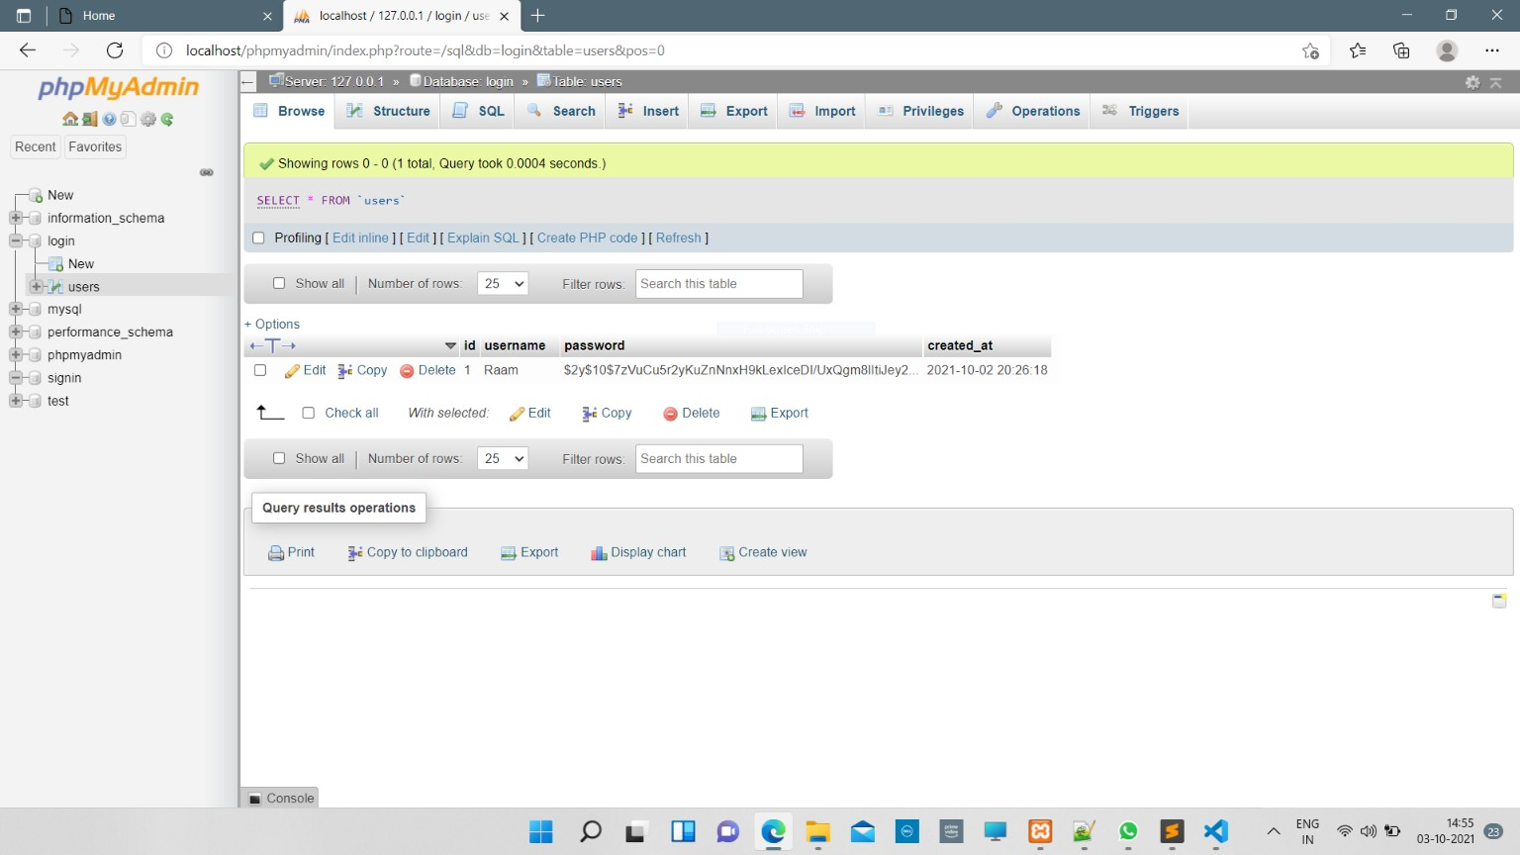

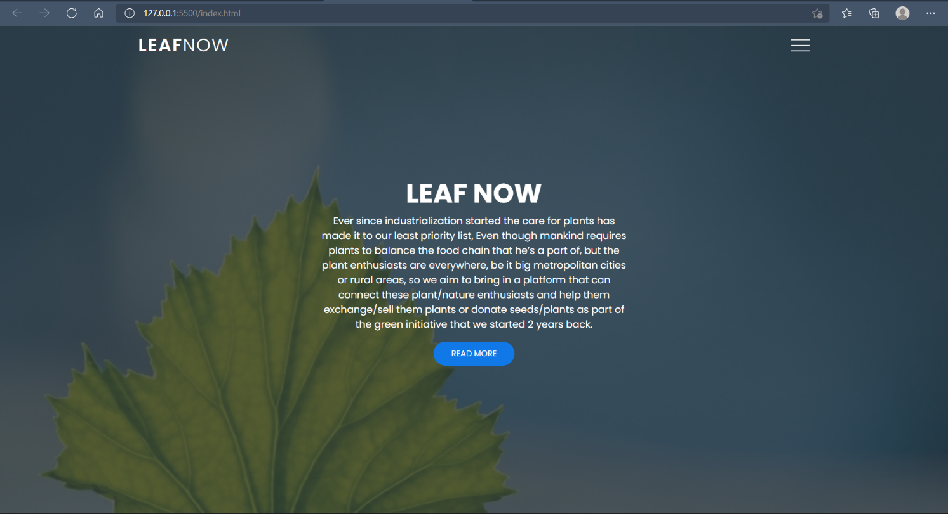

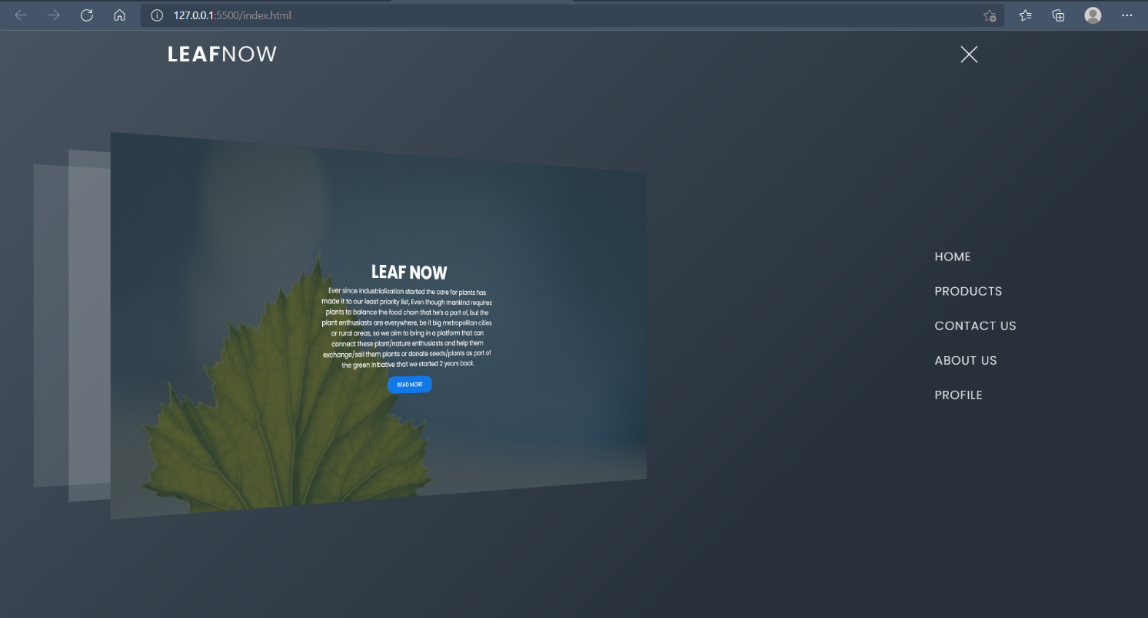

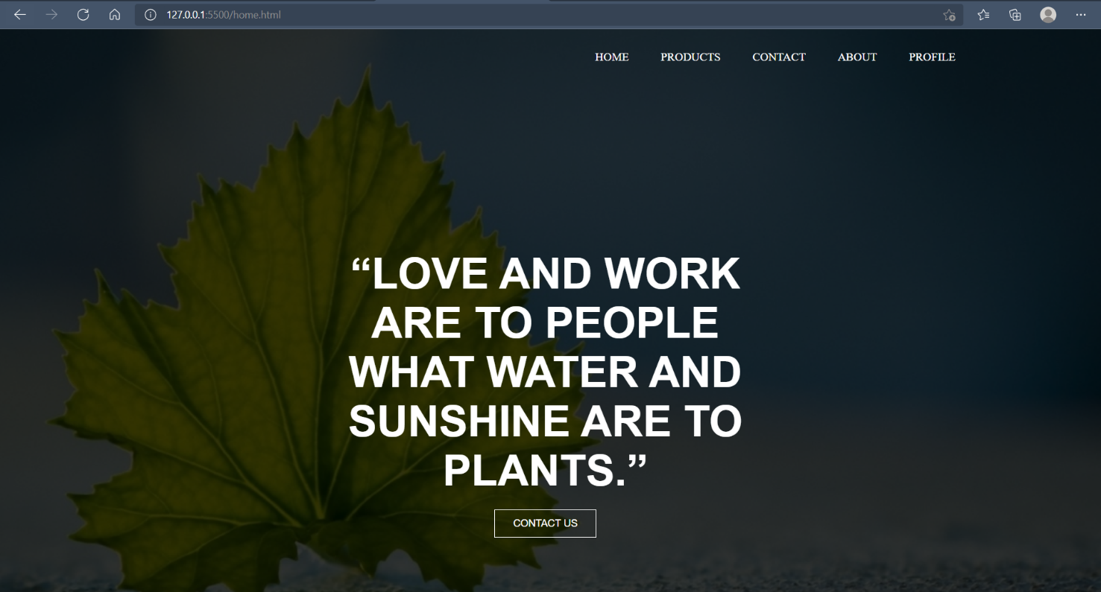

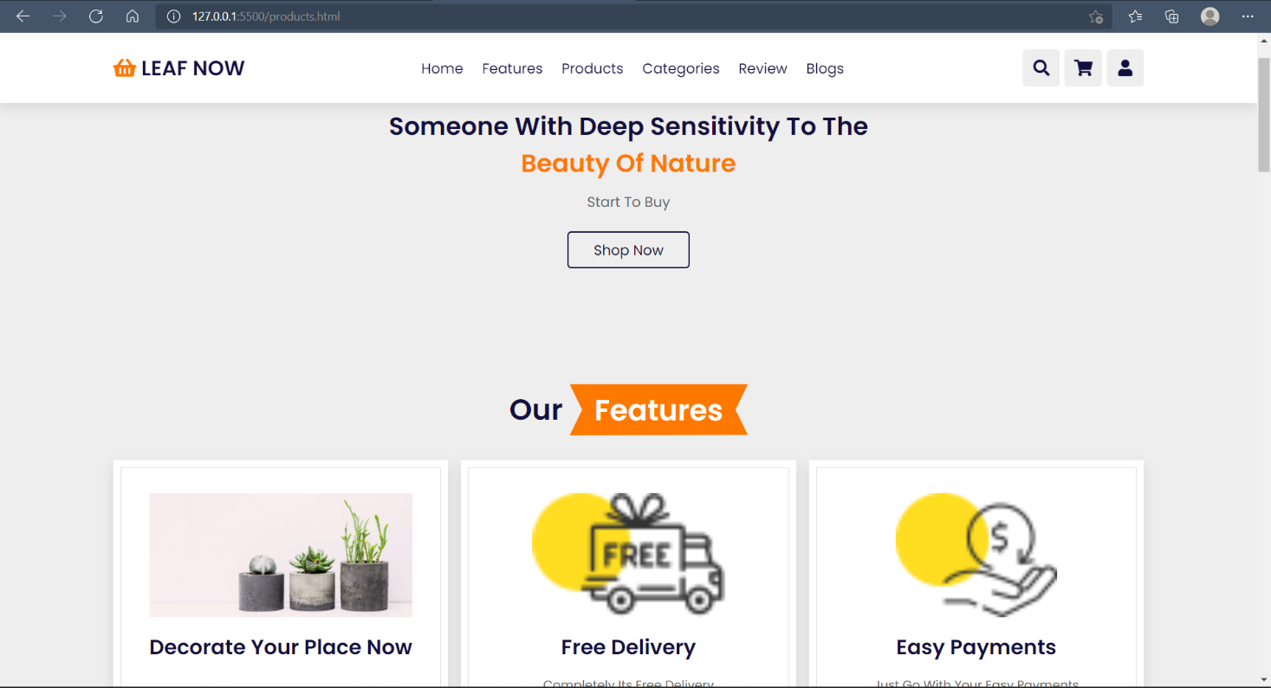

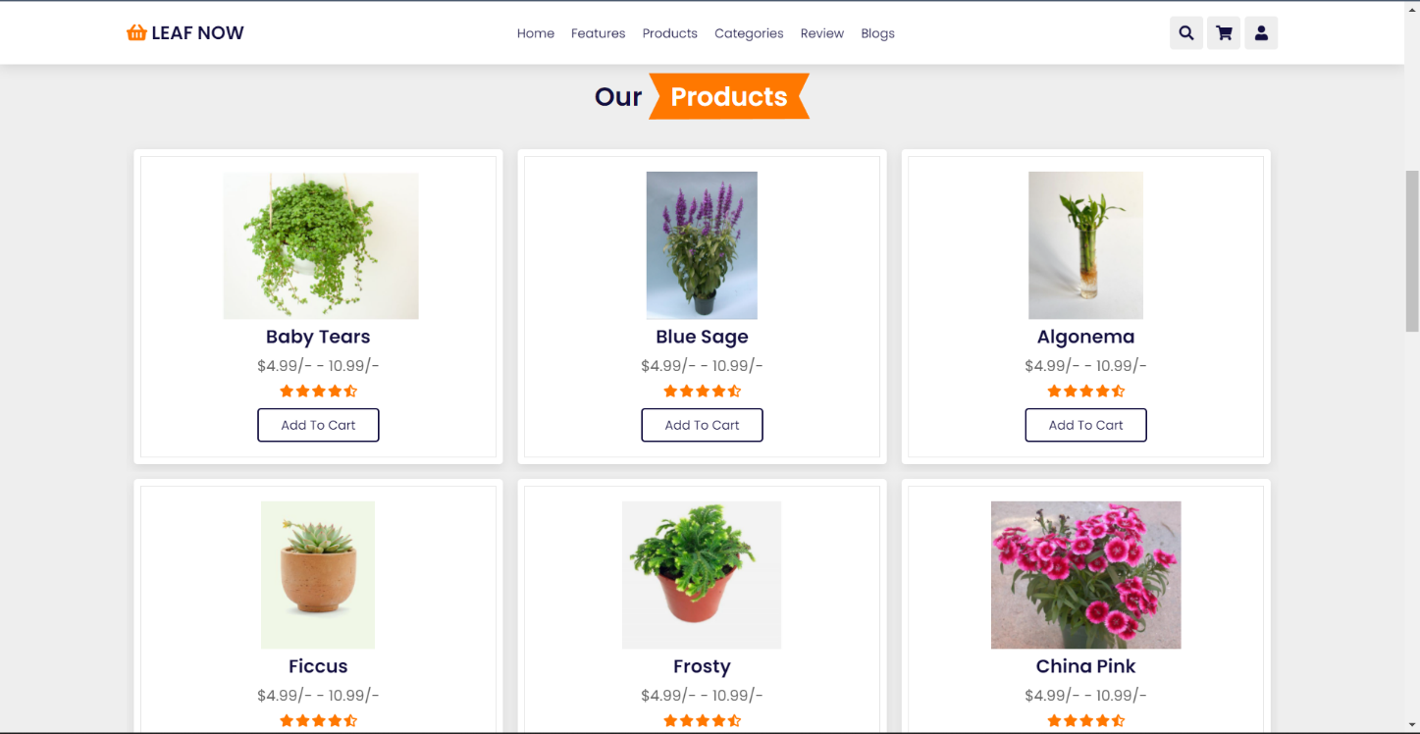

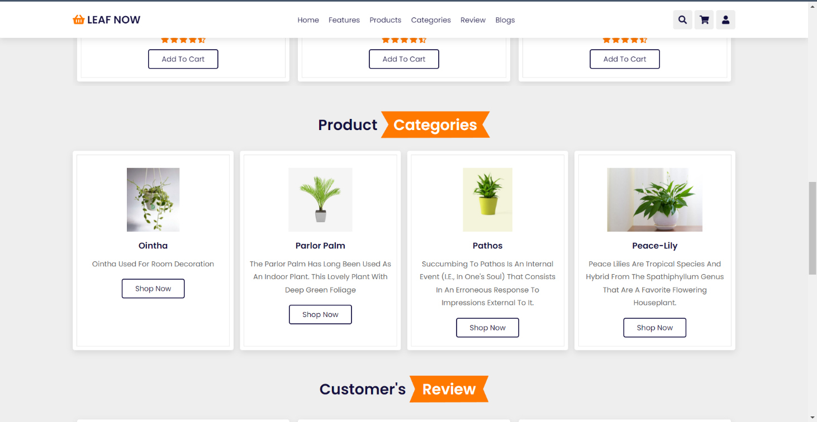



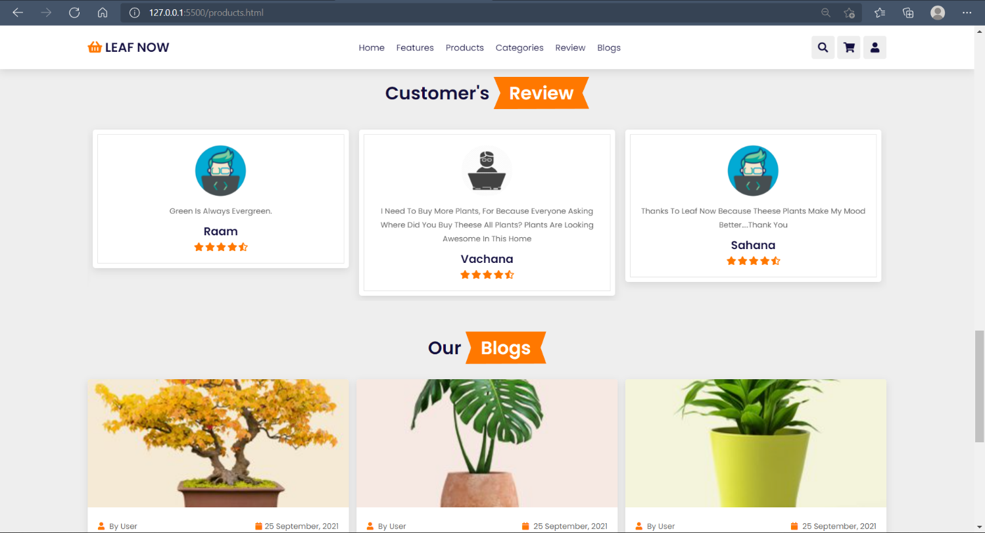

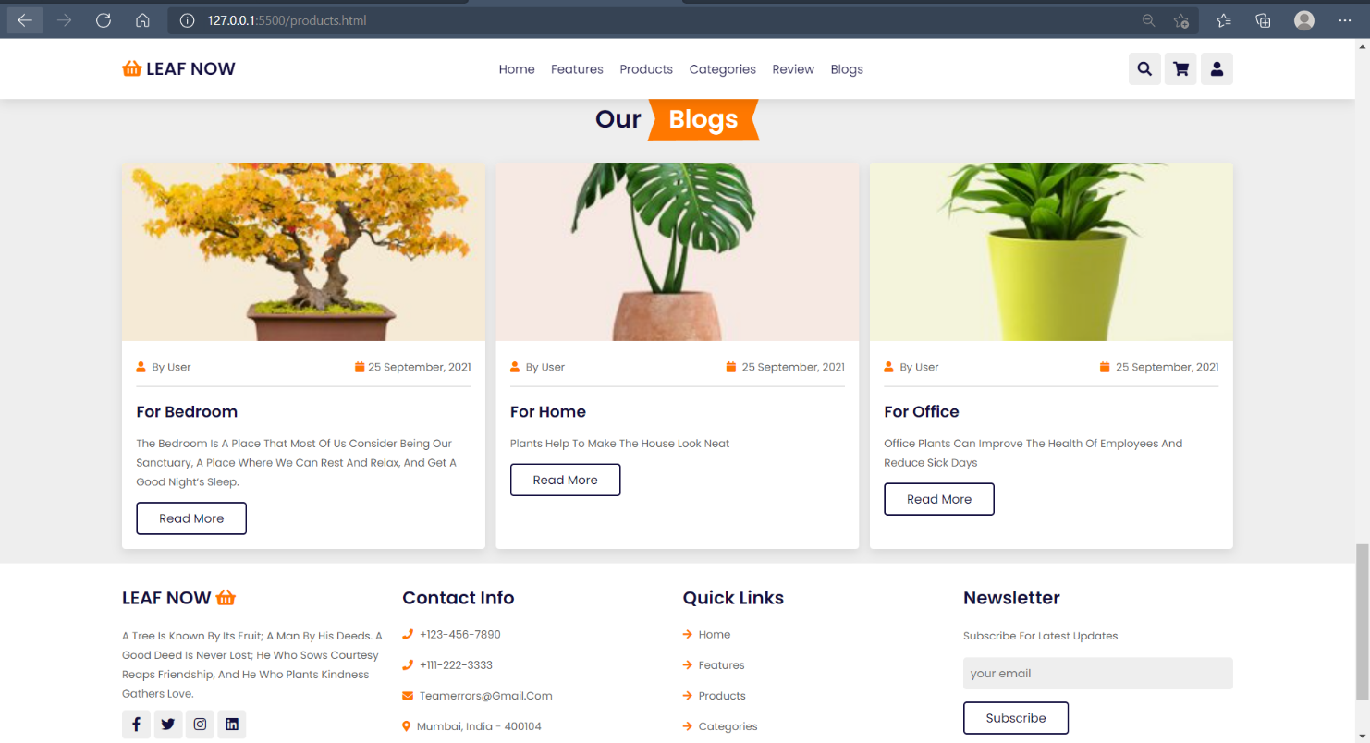

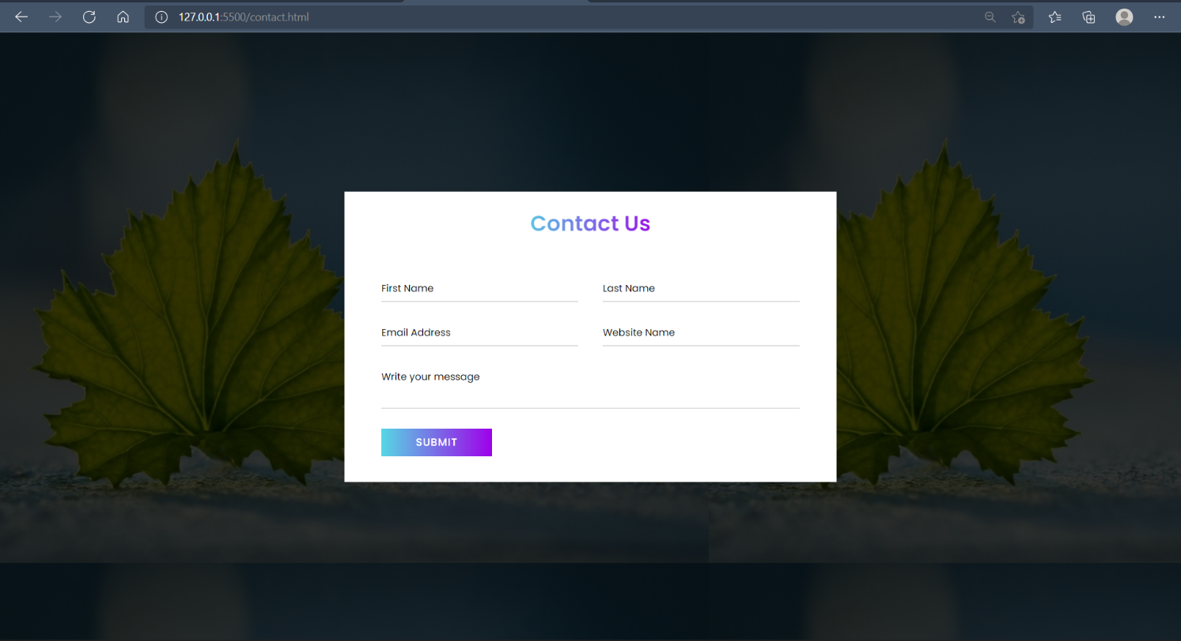

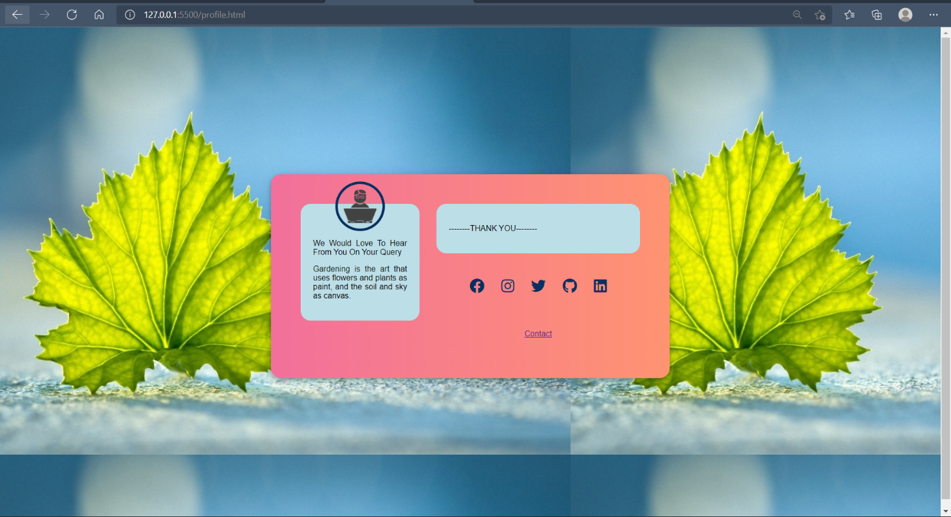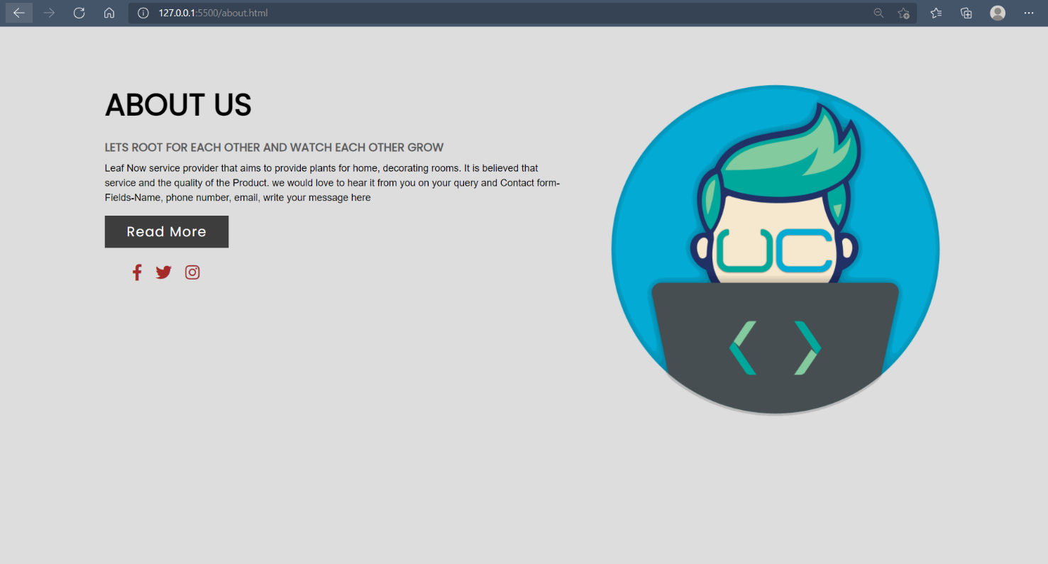

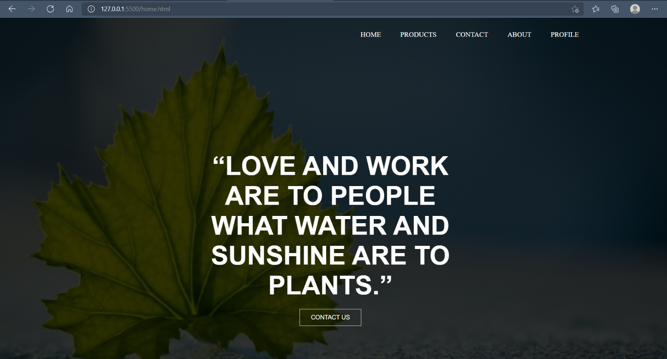

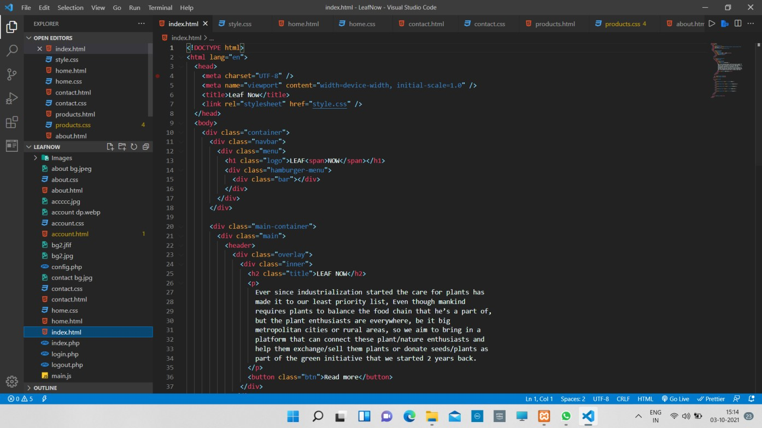

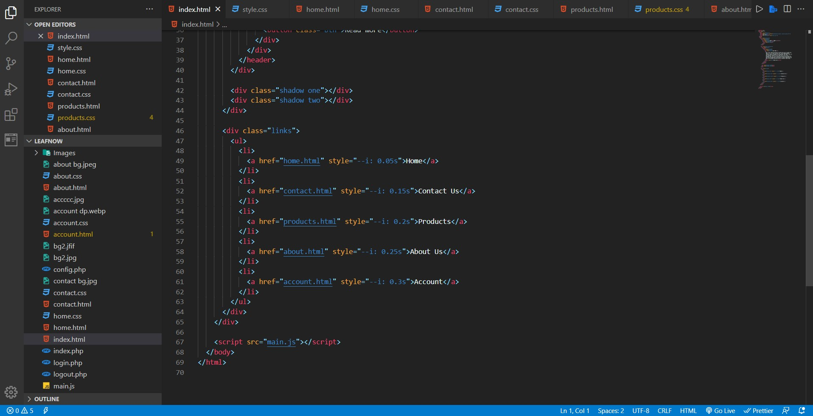

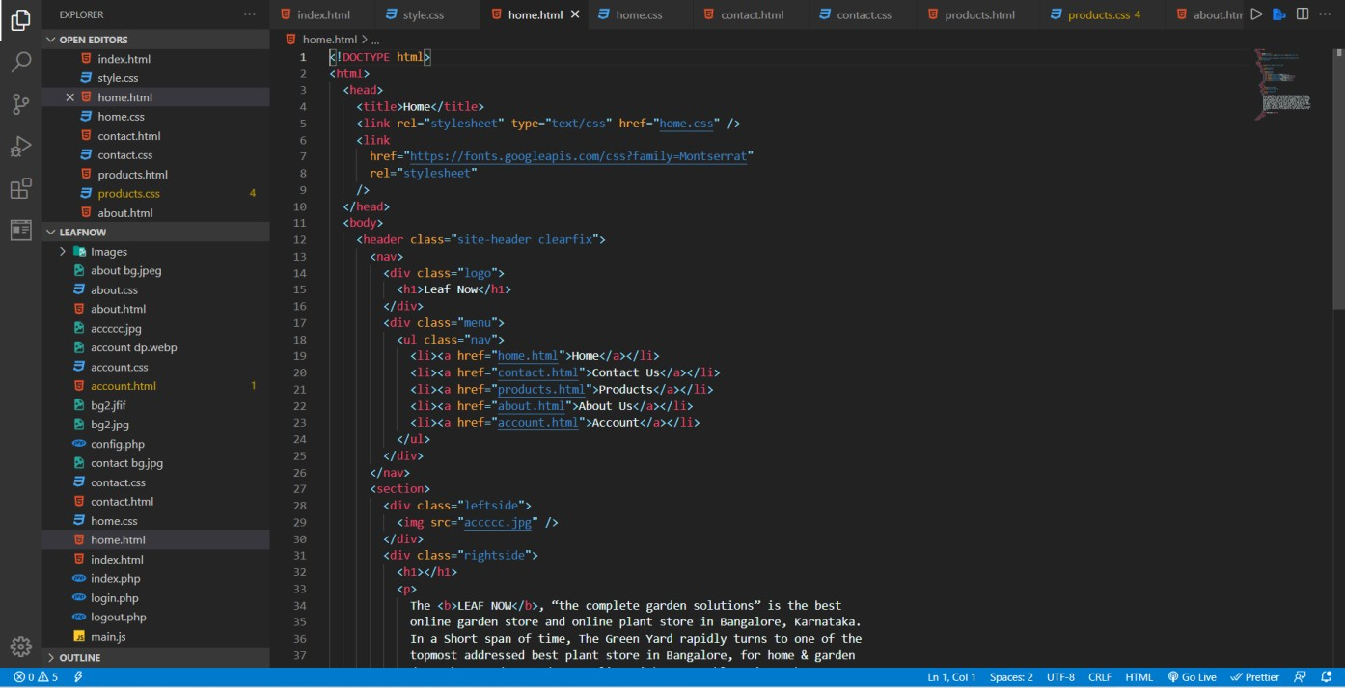

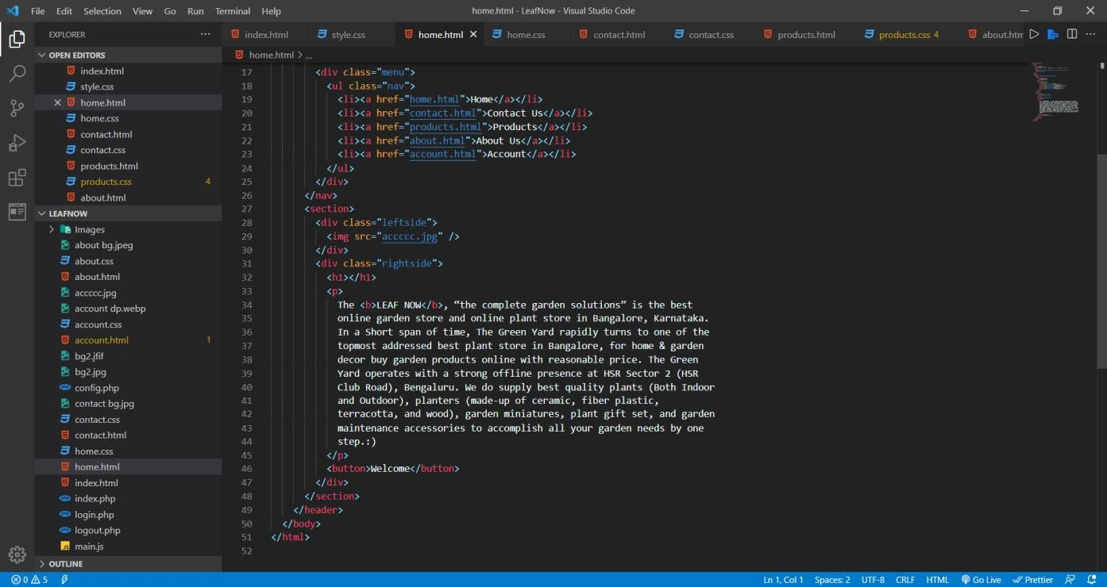

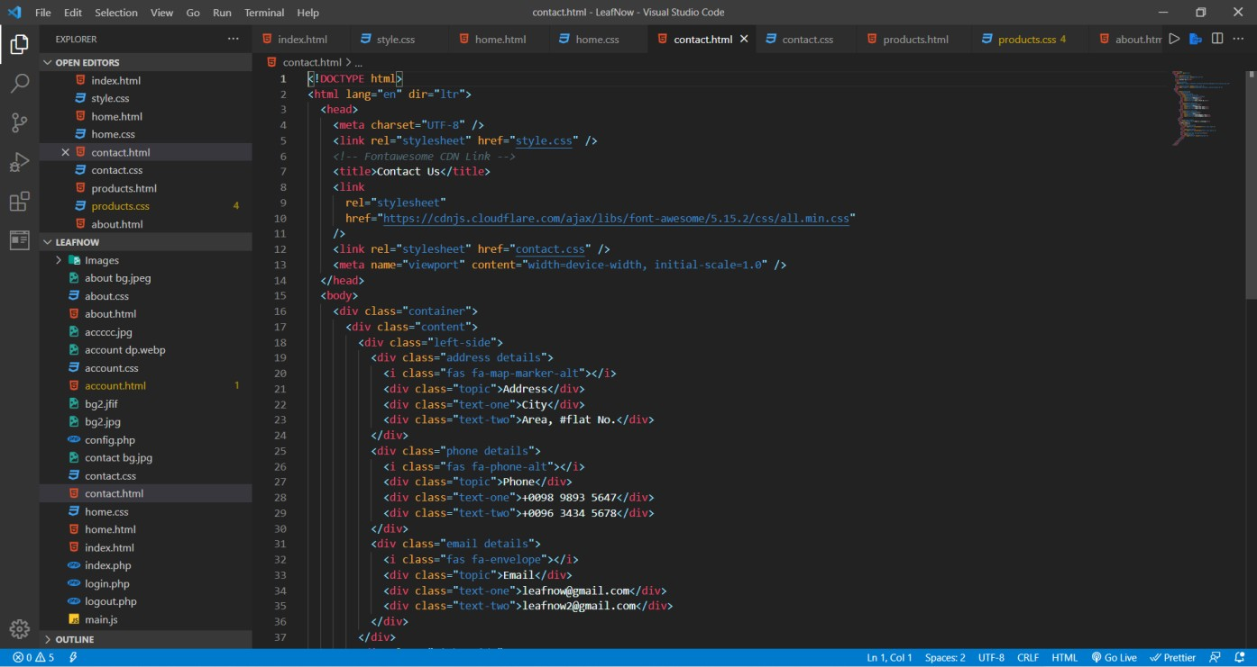

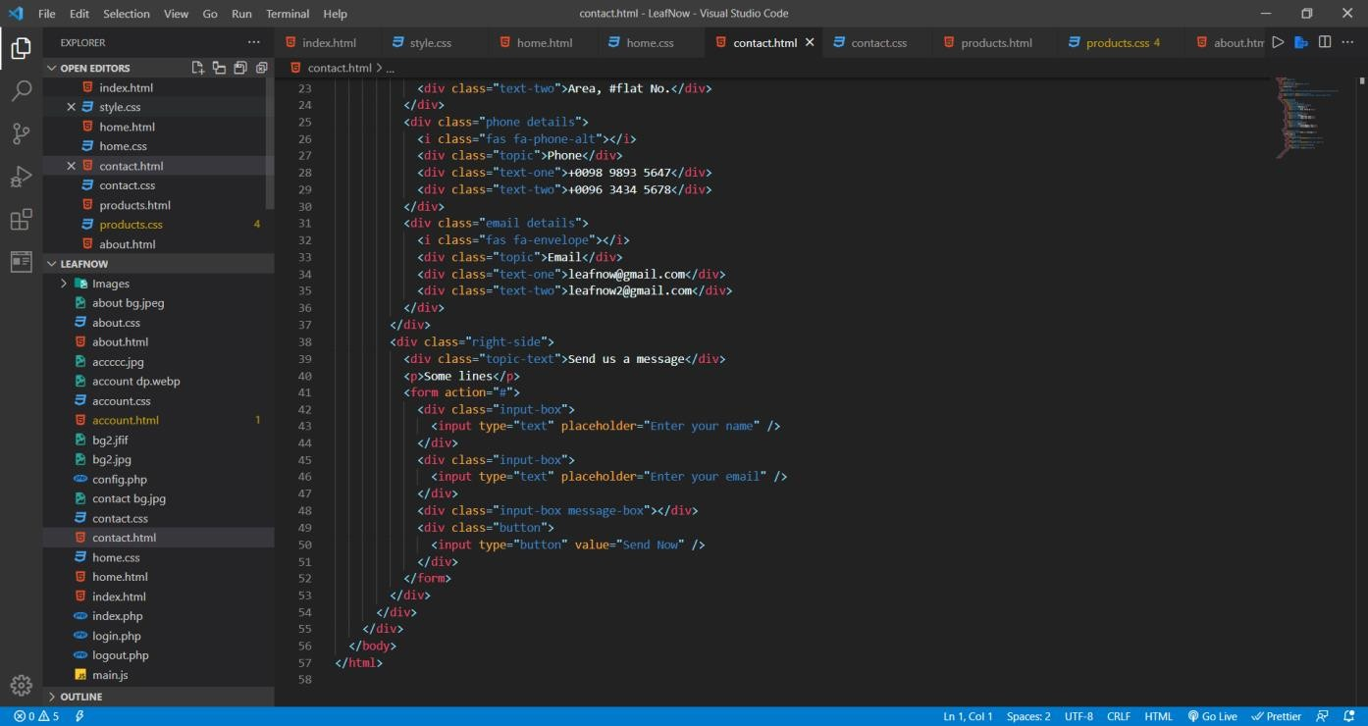

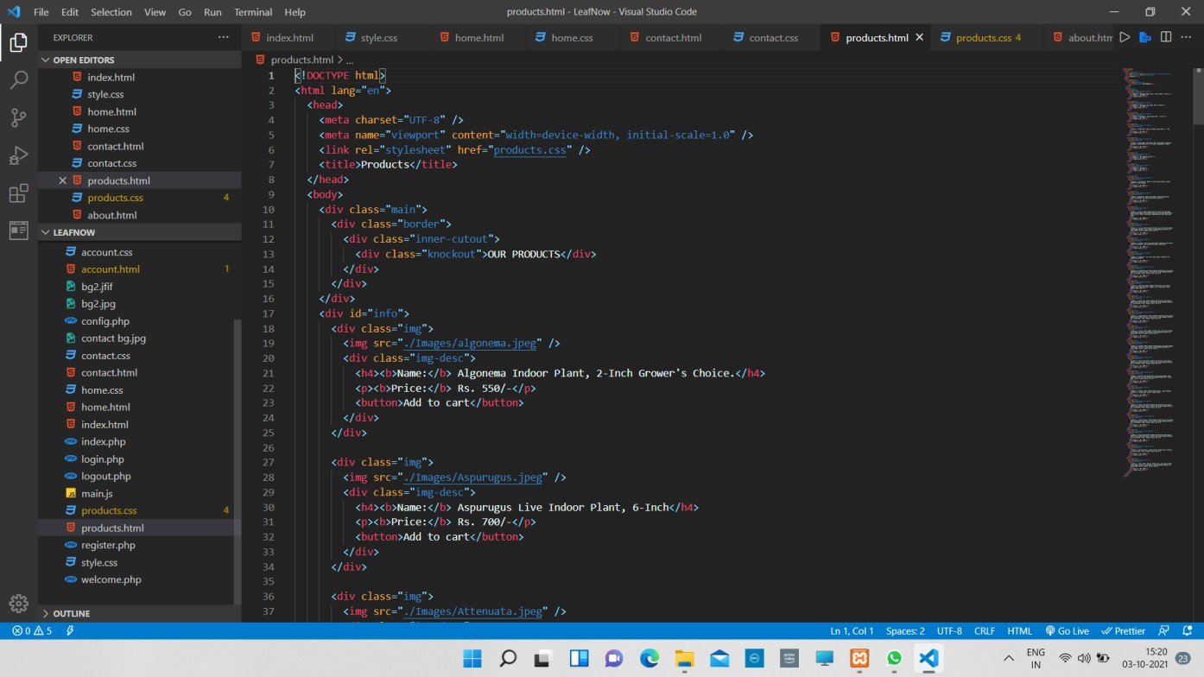

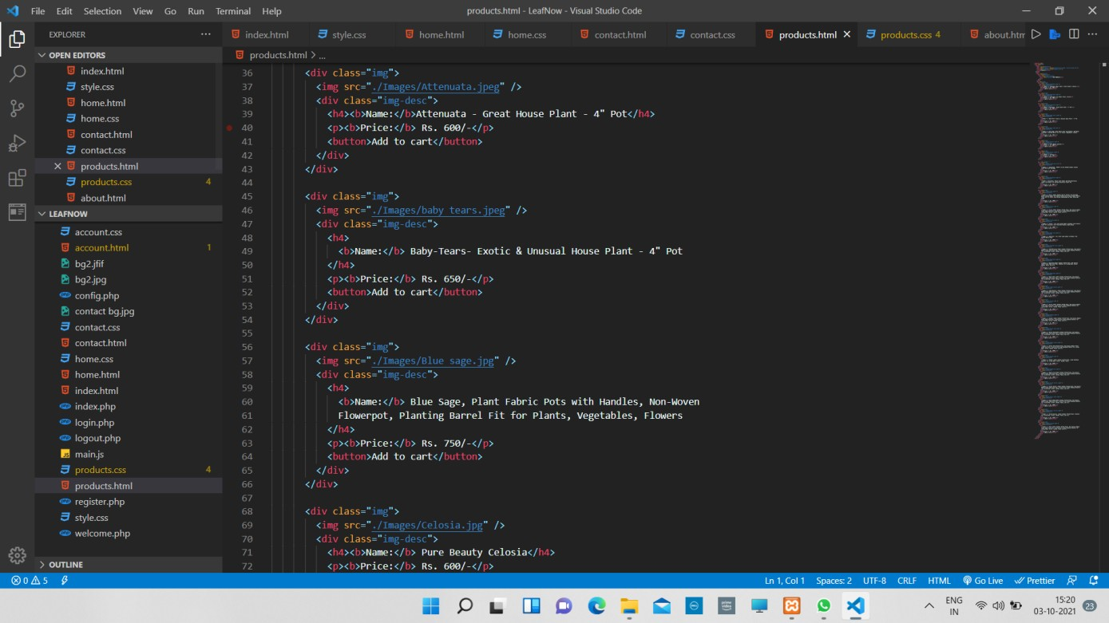

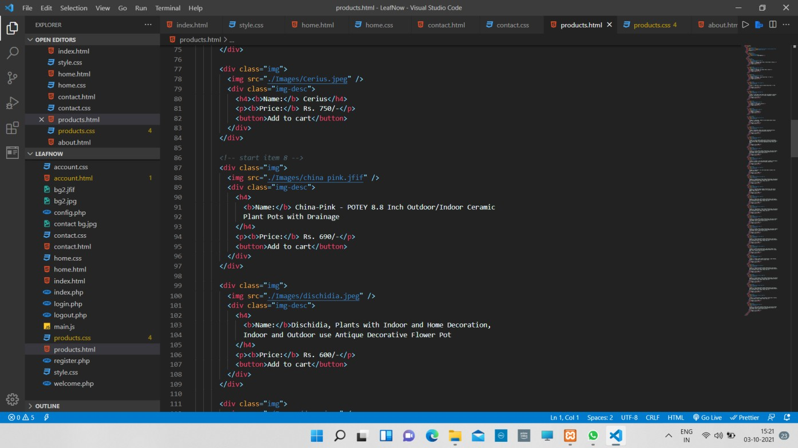

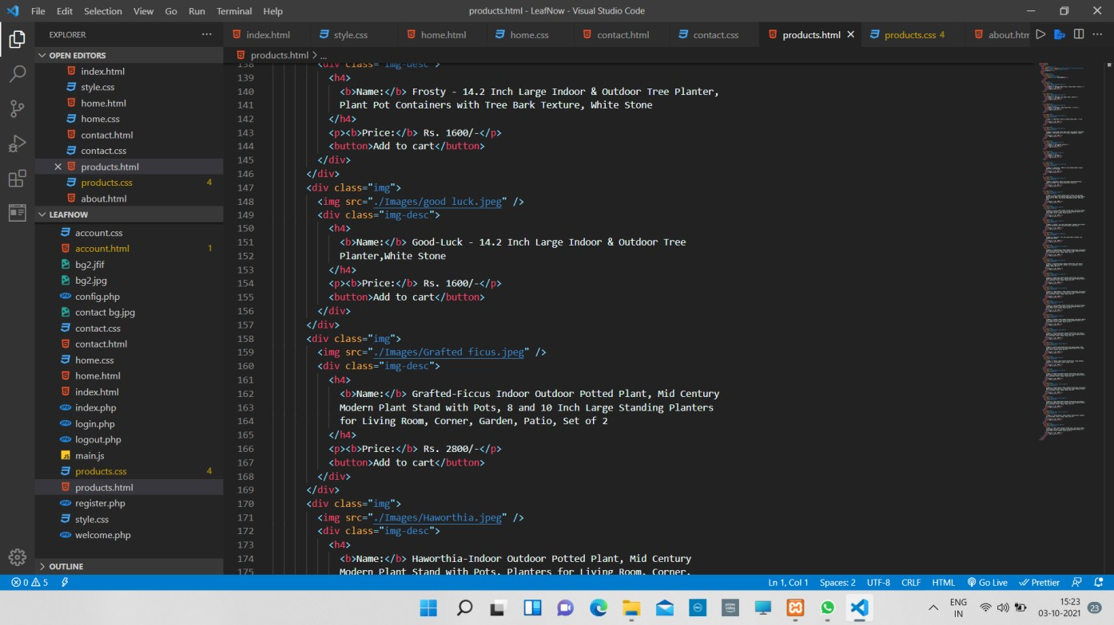

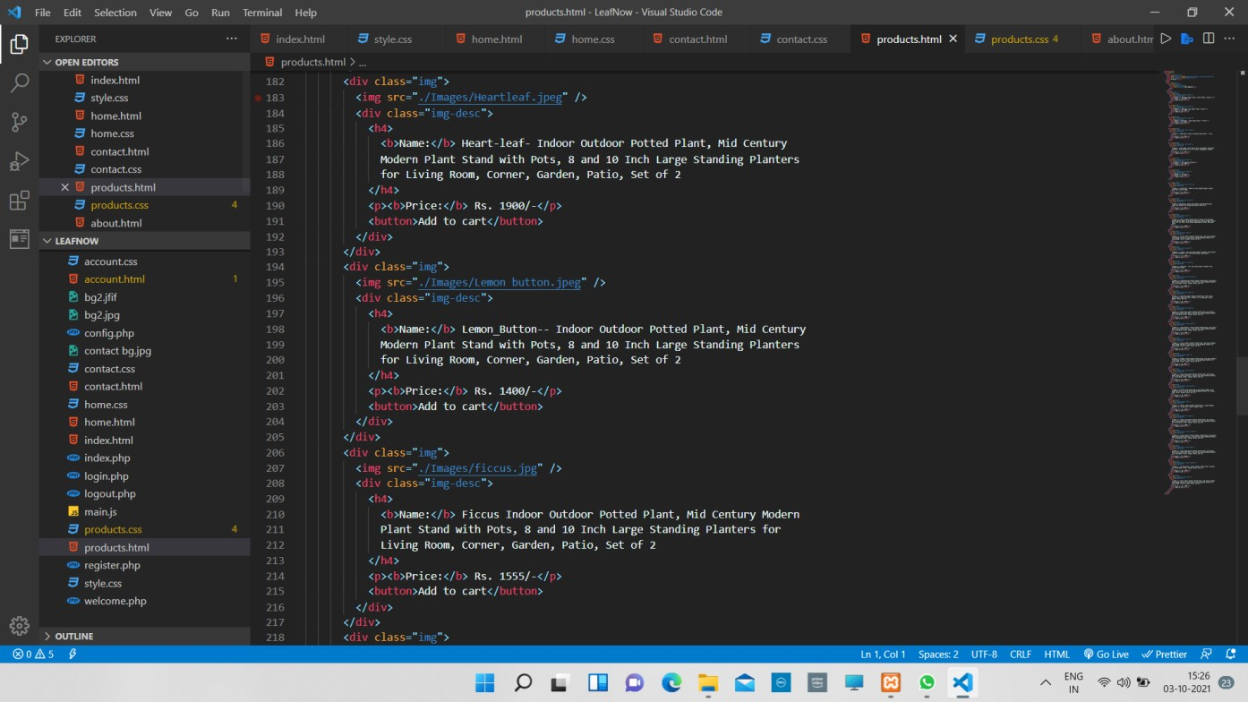

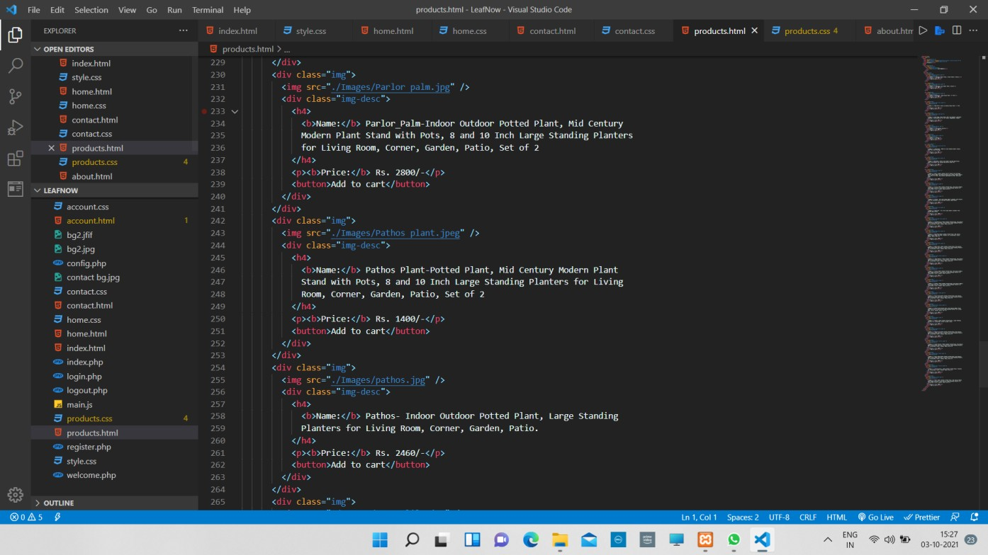

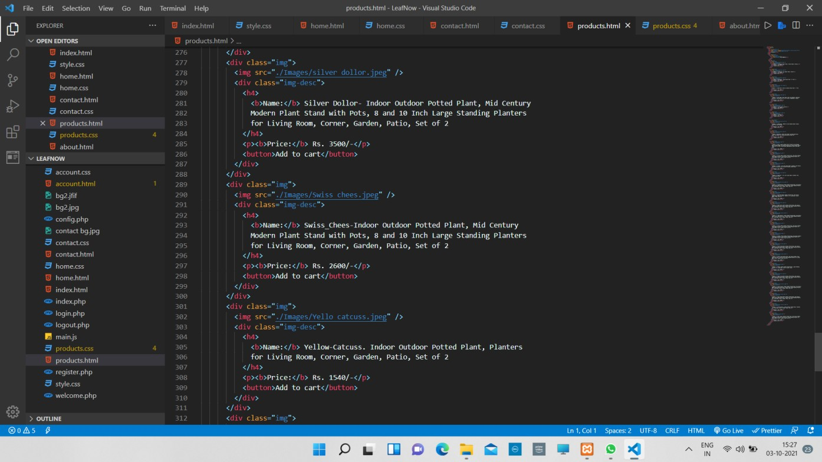

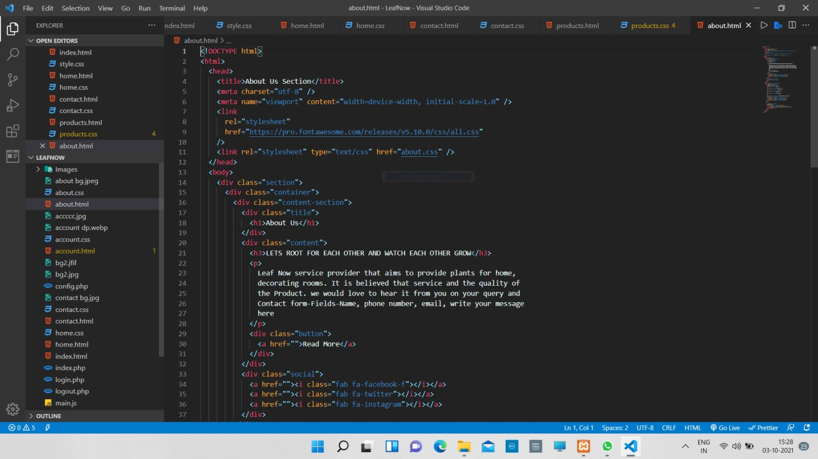

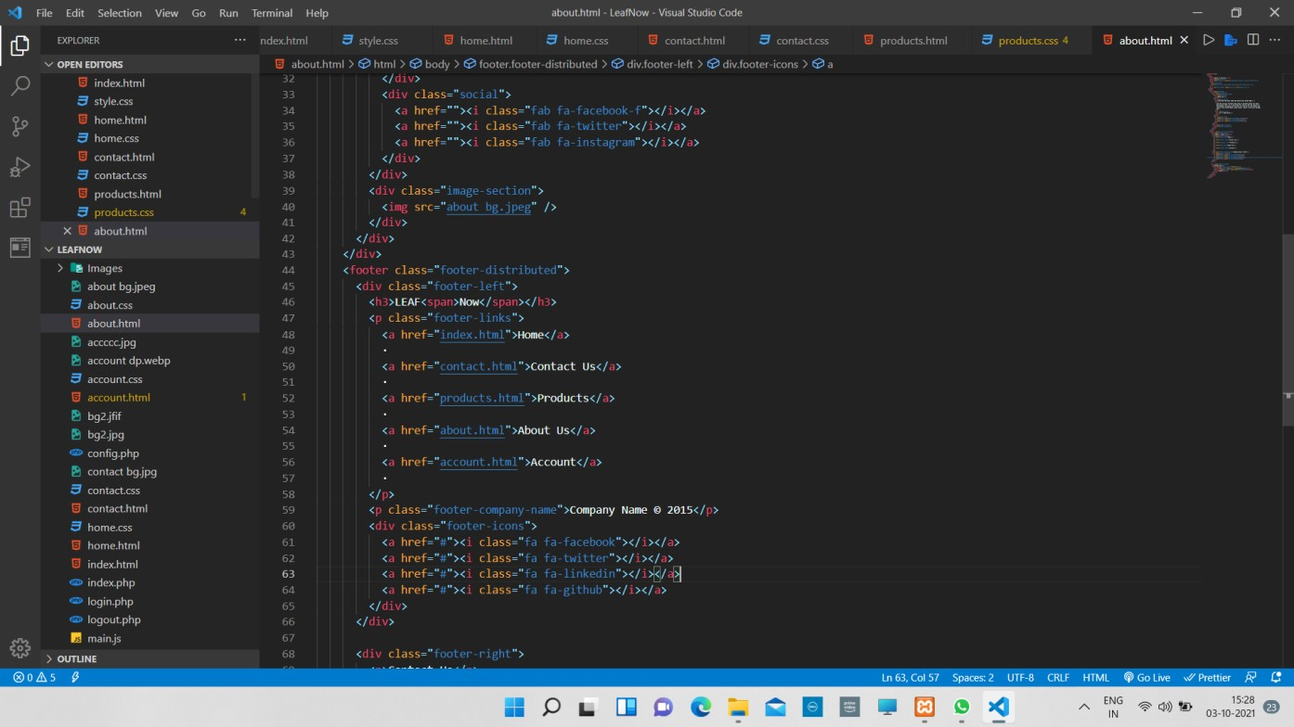

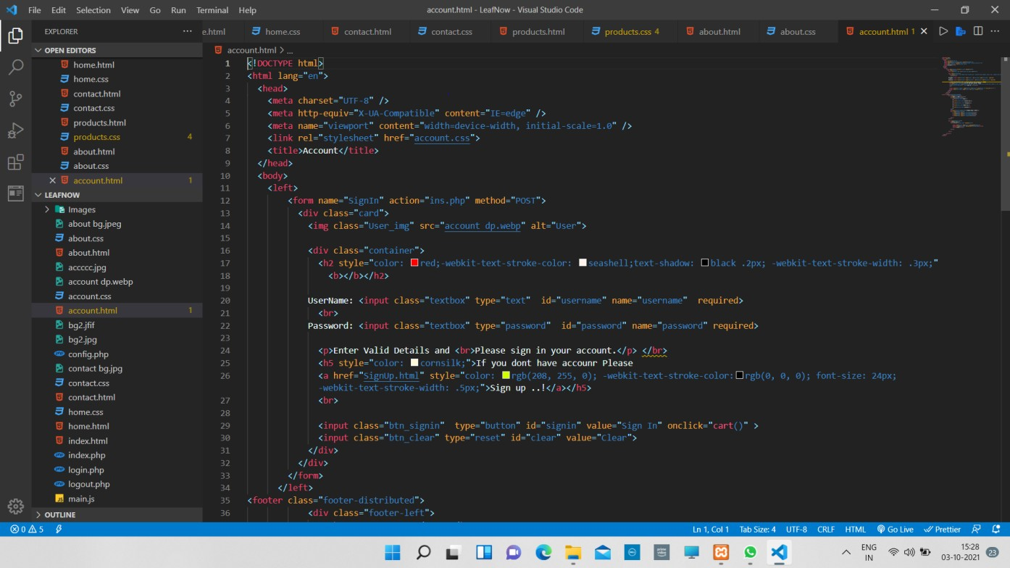

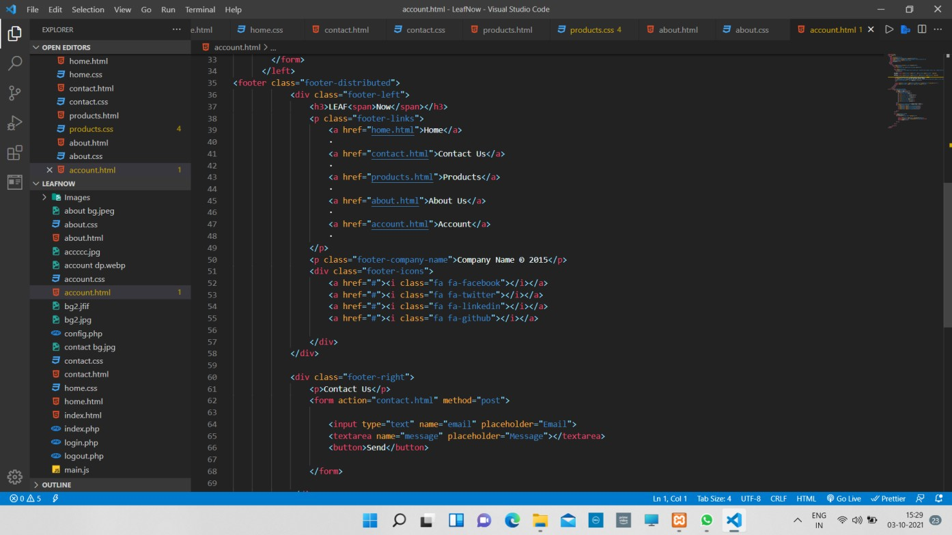

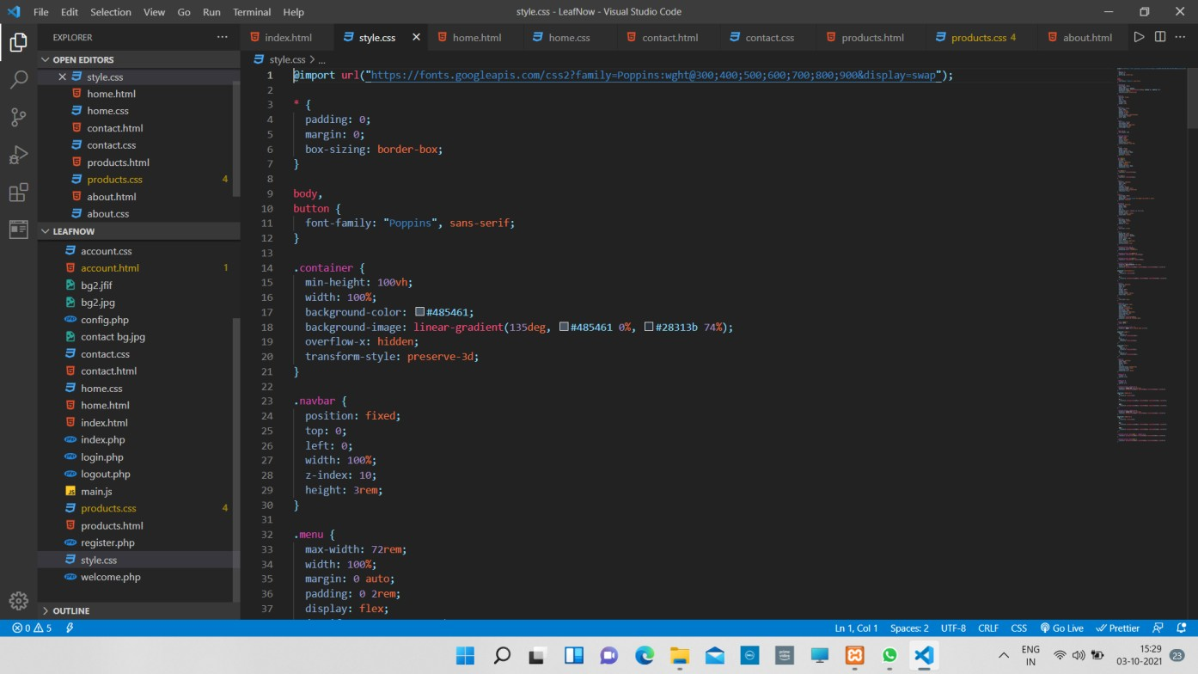

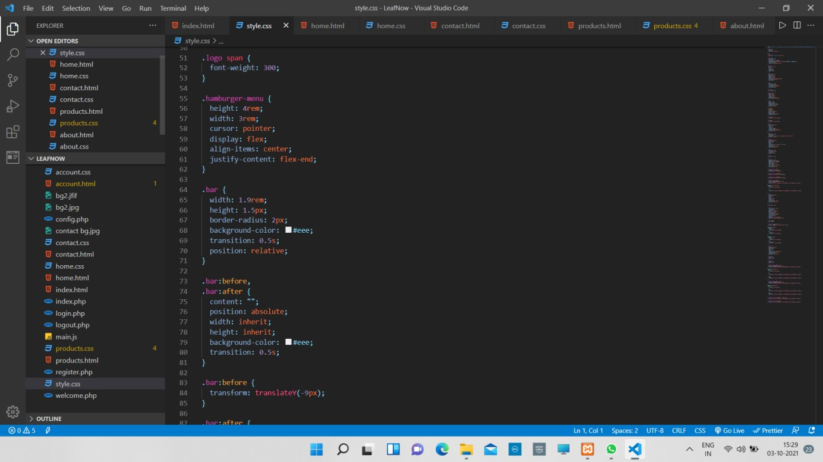

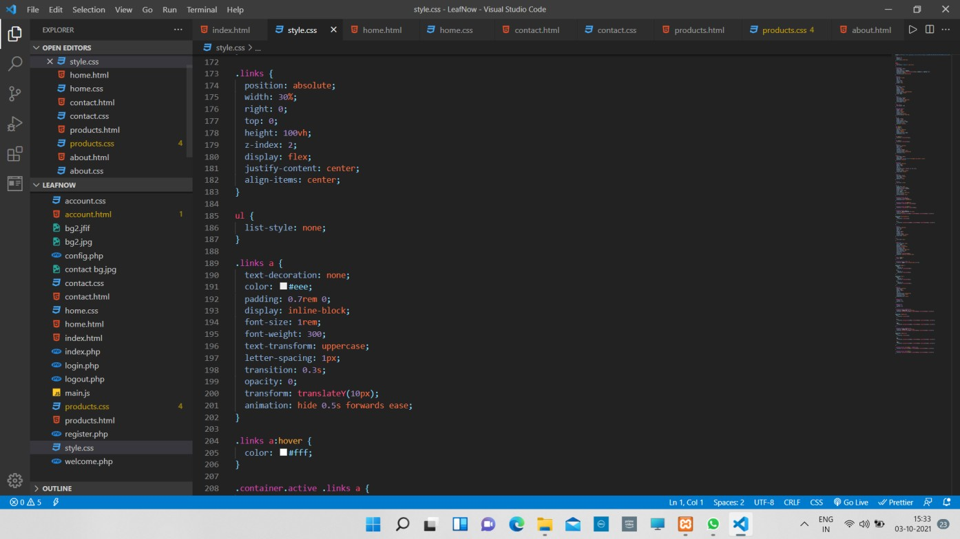

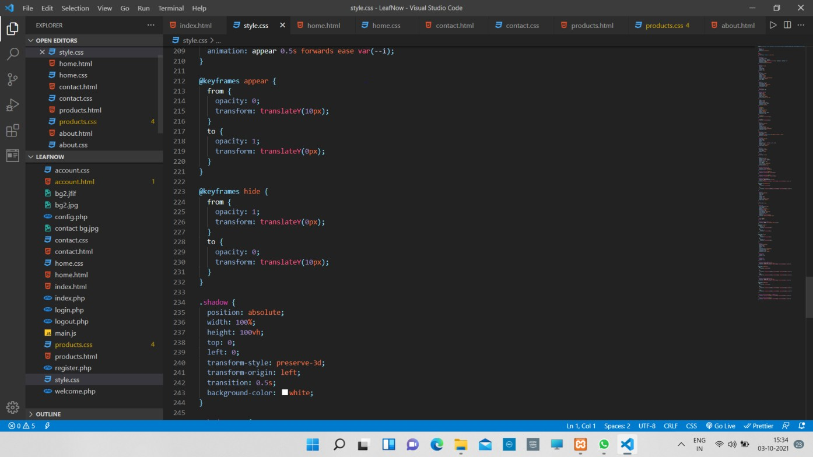

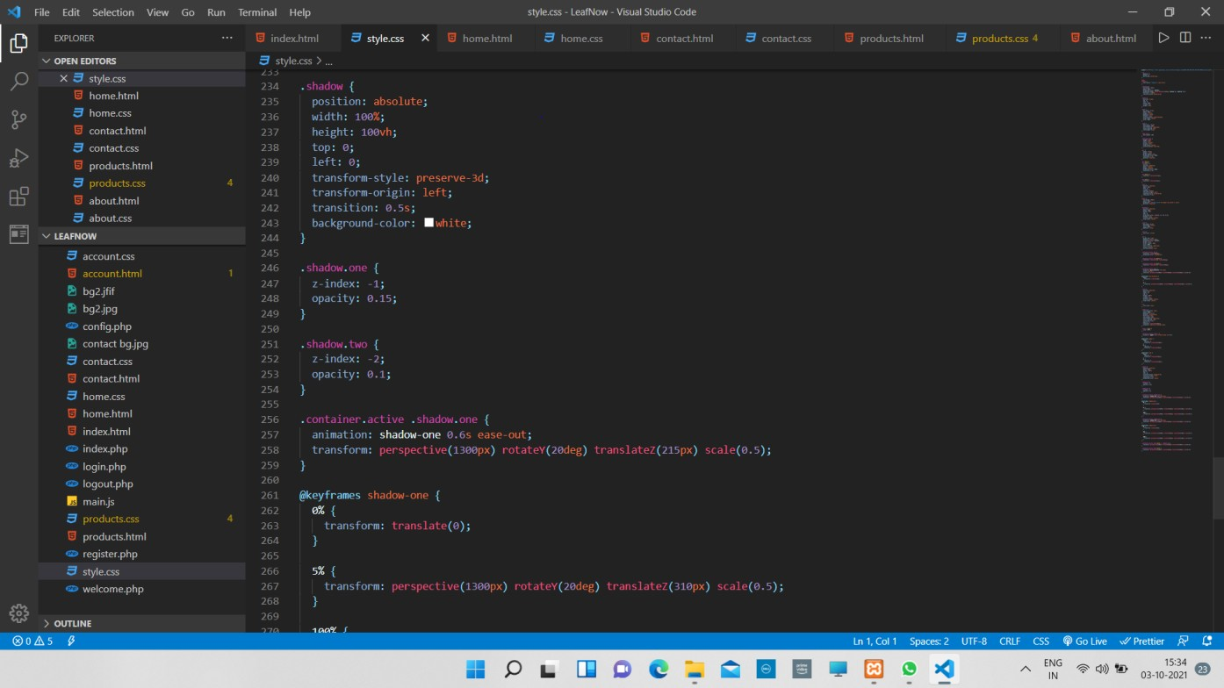

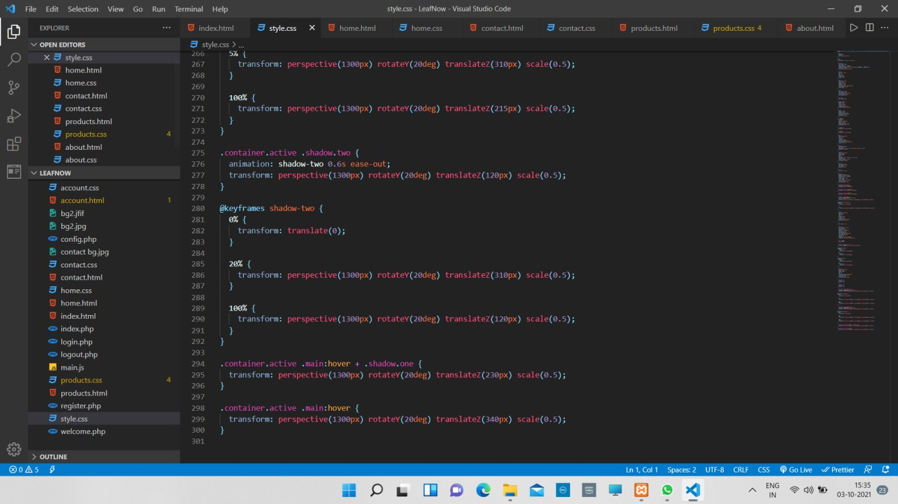

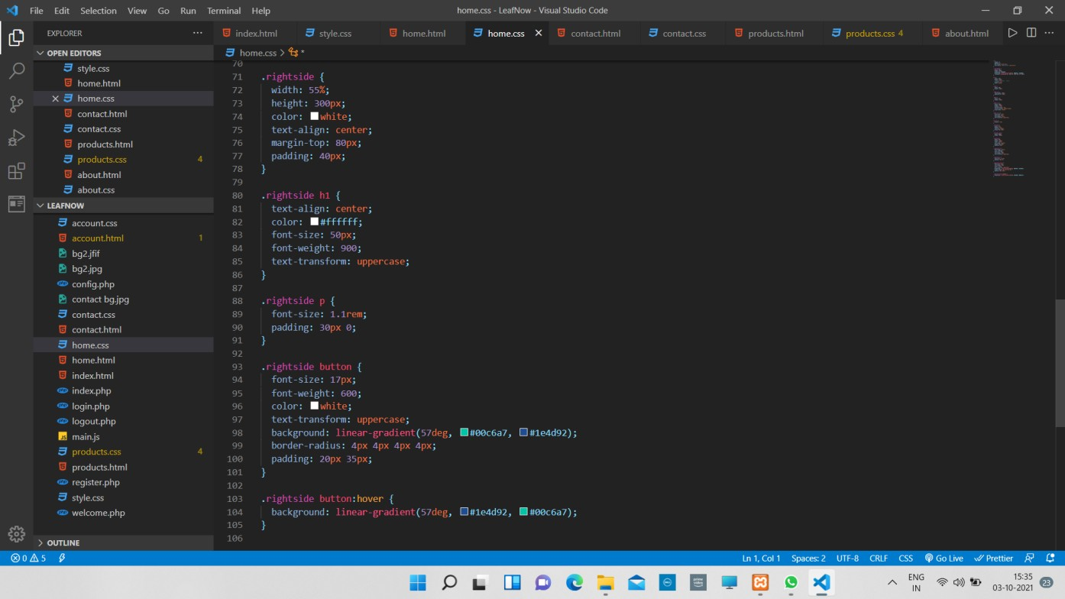

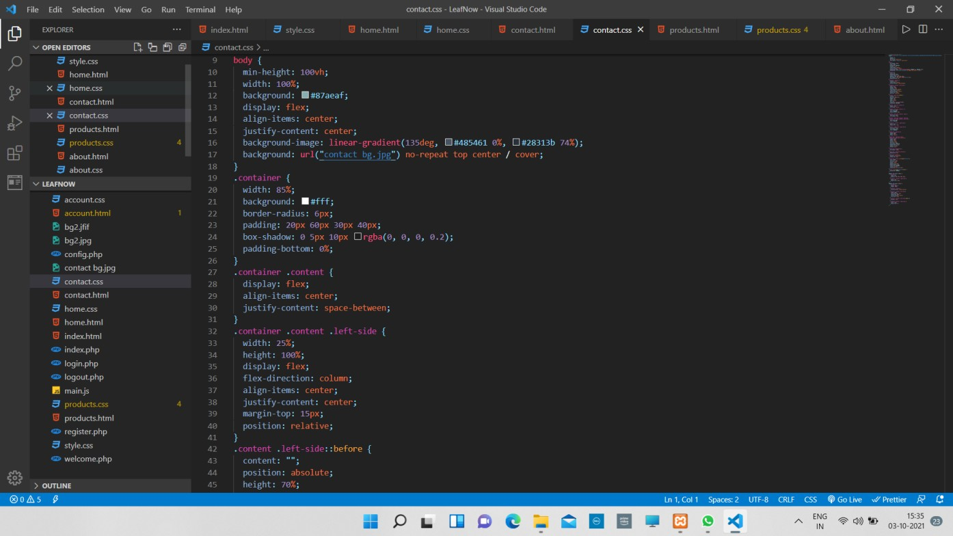

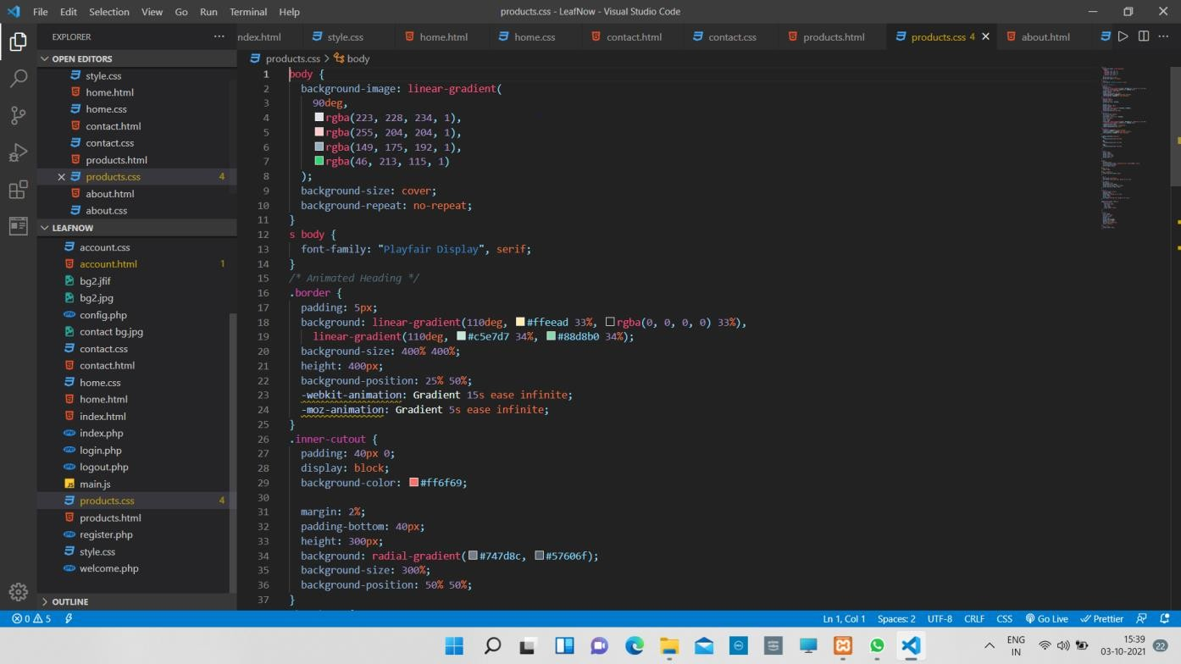

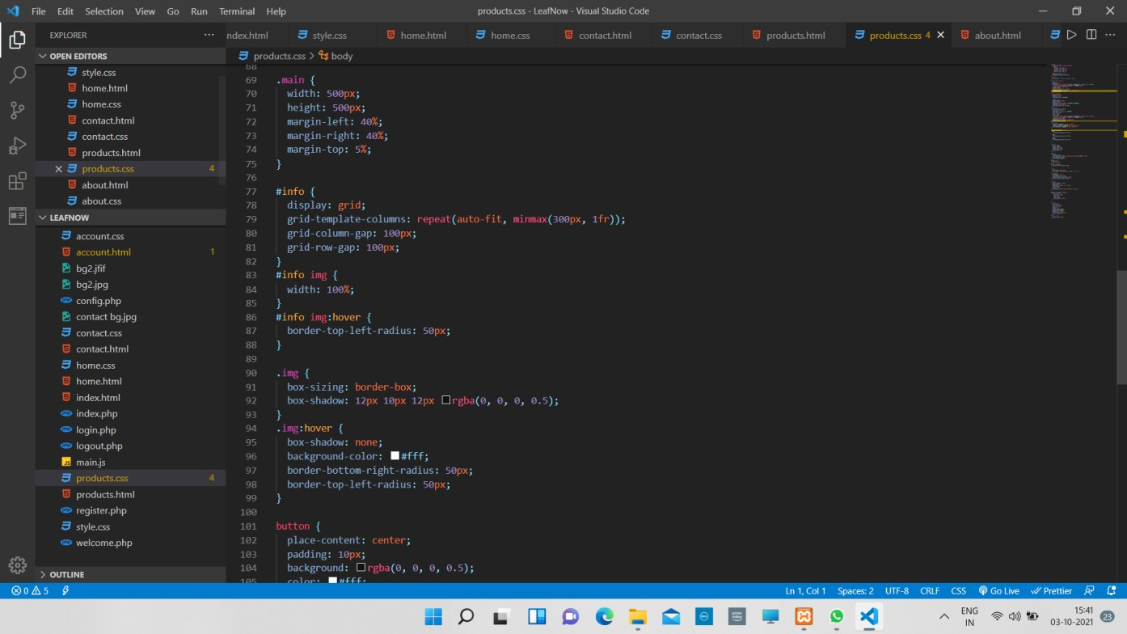

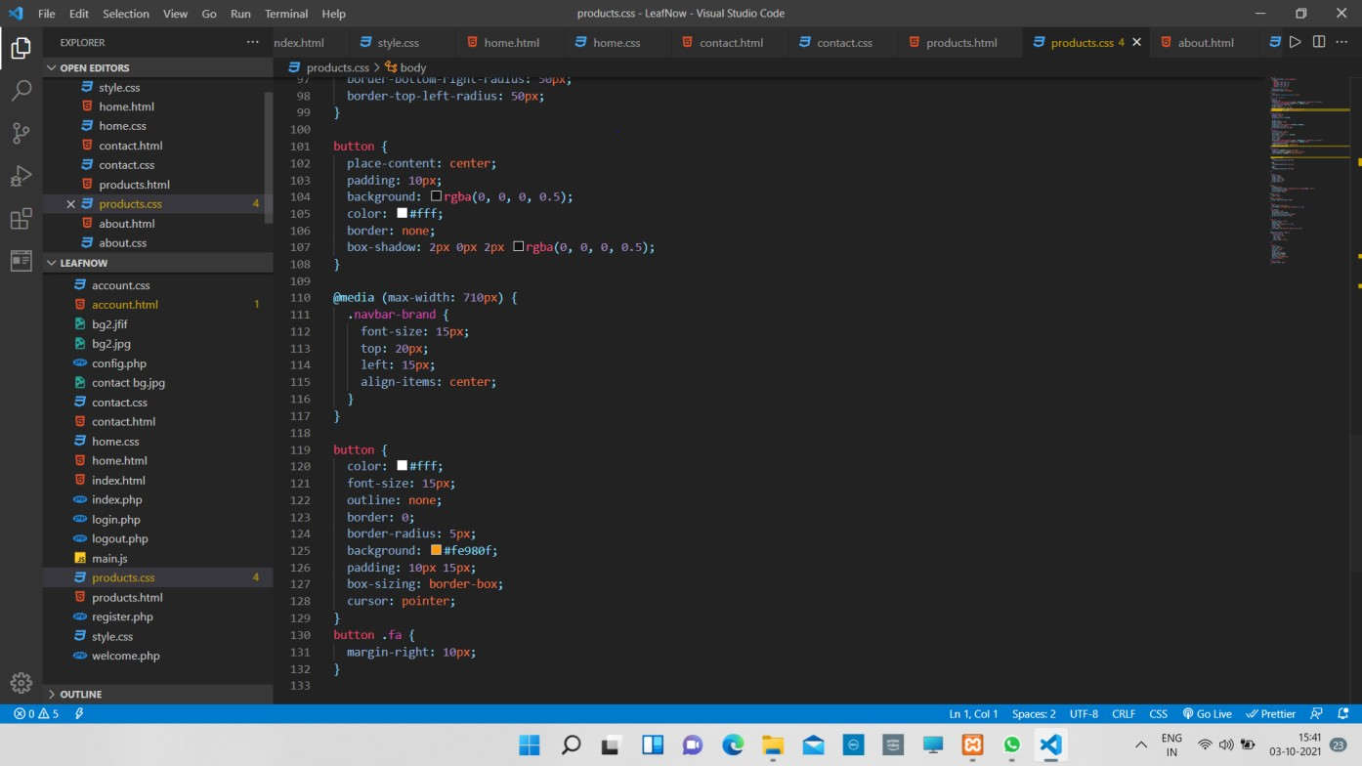

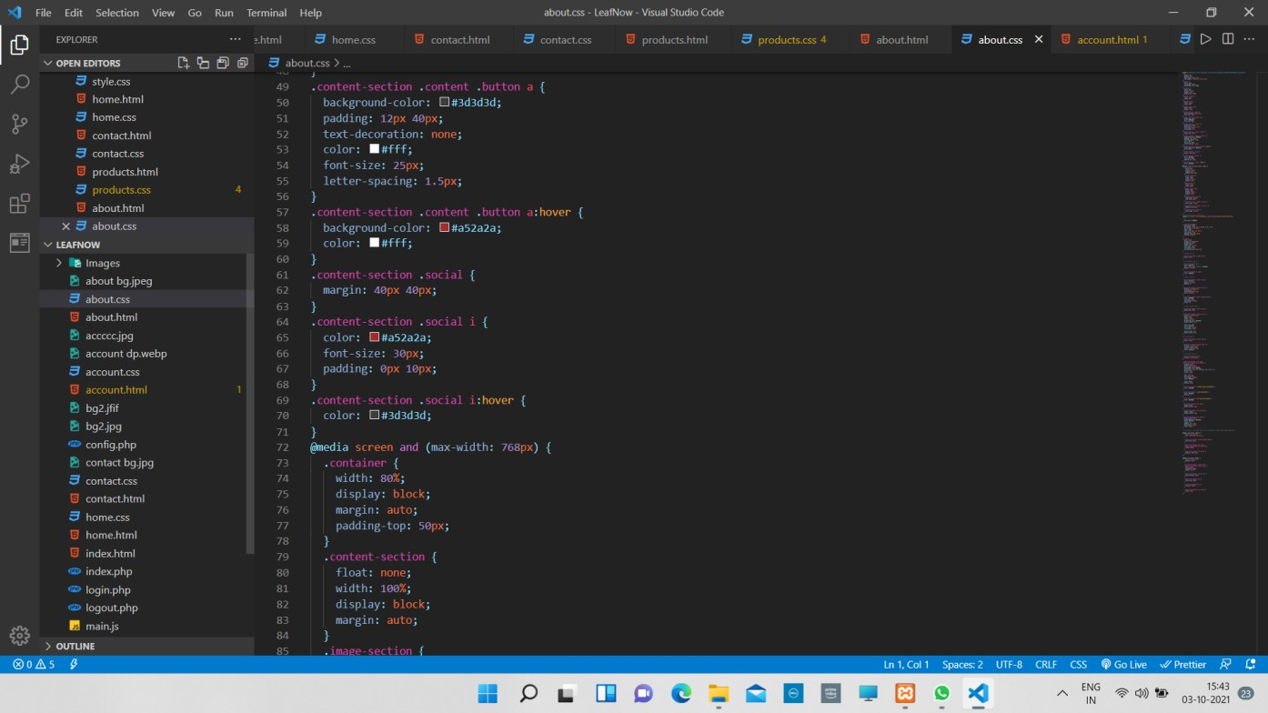

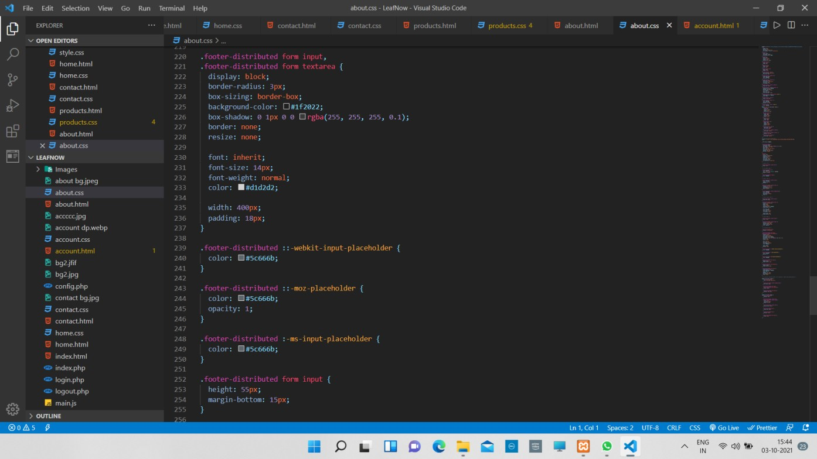

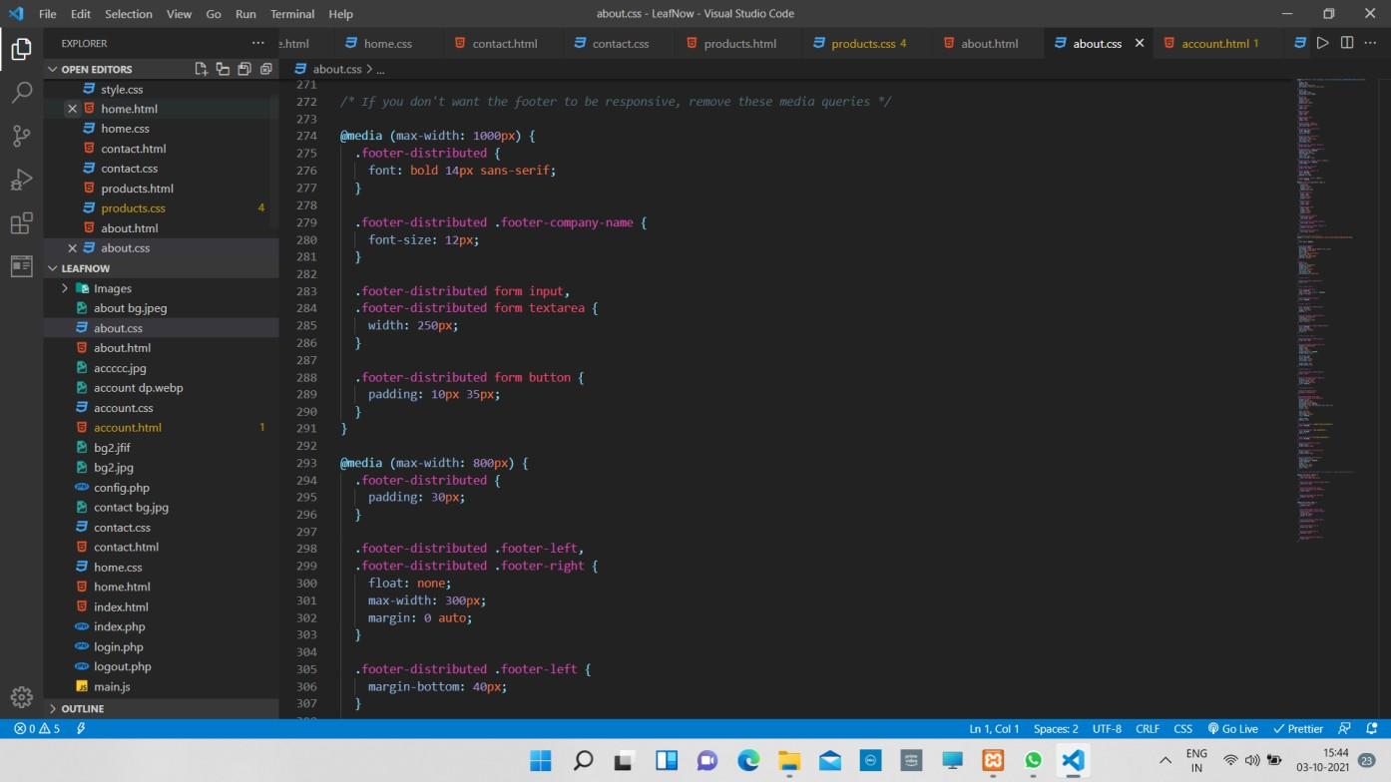

### BIBLIOGRAPHY

* https://[www.w3schools.com](http://www.w3schools.com/)
* https://[www.geeksforgeeks.org](http://www.geeksforgeeks.org/)
* https://freecodecamp.com

#### About my TEAM

Team Name: **The ERRORS.**

Team Members:

* 1. Ramkumar D (HTML,CSS)
  2. Vachana Deepthi M (HTML,CSS)
  3. Sahana R (HTML,CSS)
  4. Suhas P (PHP,MySQL)